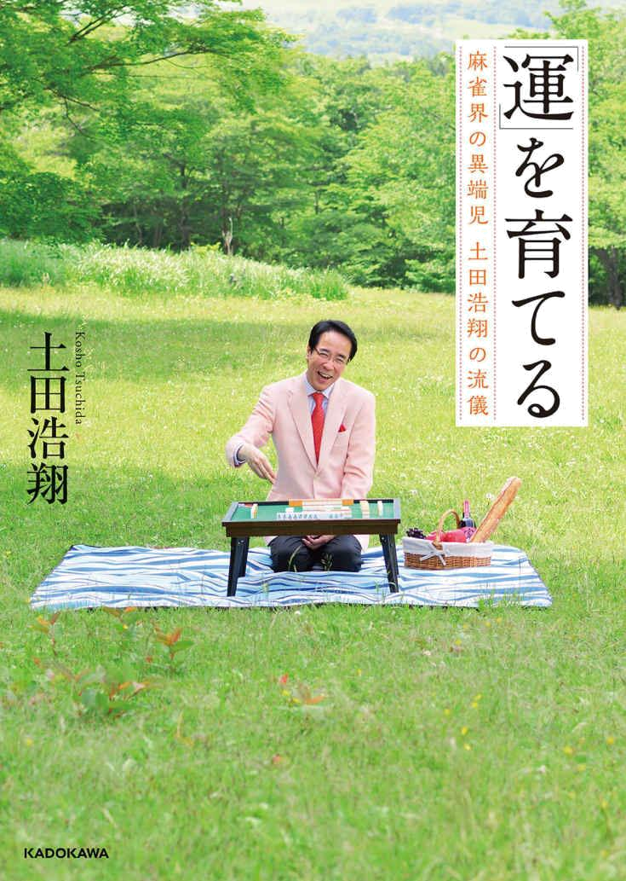

Growing Luck.

The style of Kosho Tsuchida, an unorthodox player in the mahjong world

Kosho Tsuchida

Anon notes

Flow book by Tsuchida. It is translated with deepl, so don’t expect anything great or faithful. It’s readable, but sometimes you’ll need to make up words in your head, and sometimes words will make no sense at all. I’d say you can understand more or less 70% without troubles, and the remaining 30% is up to your imagination. Sometimes Tsuchida refers to himself (or it is a translating problem) with 3rd person, try not to get too confused. The worst part should be the >calculation of >luck from the haipai, translator really gave up there.
I really don’t want to spend time rewriting this, so take it or leave it.
The message should come across even with these problems, so it is worth a read in my opinion. Expect luck, superstition, good manners, life advices and insight into a schizo mind.
To /mjg/ with love,
Anon


Prologue

What is "luck"?

Before I knew about "luck," I was passionate about collecting and analyzing data.

I believed that if you get to the bottom of the numbers, you will be able to unravel mahjong.

It was very silly.

I met my destiny and noticed the "luck" in action.

I wanted to feel the "luck" that I couldn't see from that day forward.

In order to feel, I needed to increase the "amount of awareness," so I began to look at myself in my daily life.

Once I noticed the "luck" movement, I wanted to change my ways.

In order to do so, I had to accept the "self I don't want to admit".

Cultivating "luck" led to cultivating "heart”.

By facing my luck, I have found the path I should take.

I've come to want to win the battle with my inner self rather than win or lose with others.

And I wanted to pass on the spirit of honing my "luck".

I realized that winning was more important than “winning”.

In this article, I would like to write about my "realizations" to help you realize that Mahjong.

Nothing would make me happier than to see a positive impact on my "luck”.

２０１６年 Carrying My Heart on the Milky Way

Kosho Tsuchida

Growing Luck.

Table of contents

Introduction Know your luck.

Captive of numbers
Learn about the unknown world.
Shattered Data Analysis
10 Declarations of Professionalism
Meet the Sparrow Demon and learn about "luck".
Luck is everything
The spirit of self-sacrifice

Chapter 1 Noticing Luck.

1 Biggest part of luck.
2 Anthropomorphize everything.
3 Ways to Measure High and Low Luck
4 Luck recovery method
5 Change the procedure and change your luck
6 Affirming Mistakes.

Chapter Two. Growing Luck.

7 Write down the self you don't want to admit.
8 How to Correct a Disturbed Mind
9 Open your mind and open your way.
- Look down on yourself.
- Philosophy of the east and south fields
- Encourage patiently.
- Predictions are everything.
- Value your intuition.
- You're so caught up in your loss that you lose everything
- What I'm trying to do to prepare for the game

Chapter Three. Face your luck.

- The setback I experienced at age 50.
- Out of place.
- The last game with a person loved by the tiles
- When in doubt, choose the painful one.
- More important than "what to cut
- The difference between "Live Action" and "Commentary
- Building True Communication
Chapter Four. Improve your luck.

24 The spirit of "Paihin Gao
- I want to be strong. To everyone who wishes to do so
- take the initiative
- A simple "mock-up"
- The "greetings" and "posture" that bring in luck
29 "Sui-Tai" means compassion
- Knowing how to be a rastmaster
- Top Tips
- complement each other
33 Worst 10 "low tile products
- Respect for the tiles

Postscript
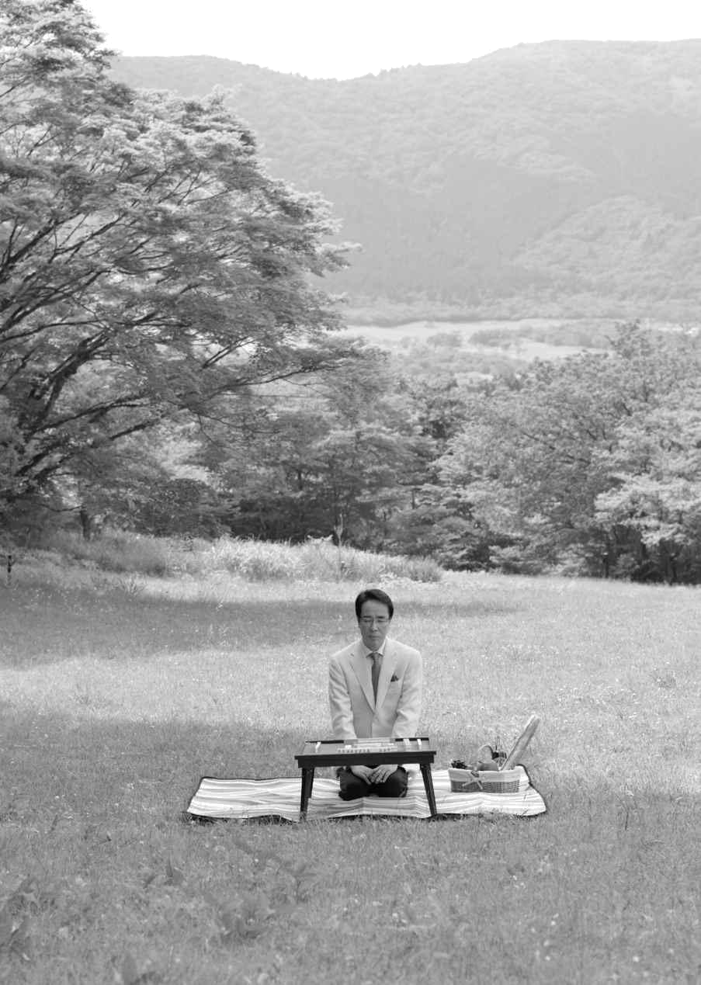

Introduction Know your luck.

Captive of numbers

captive
Growing up, I was fascinated by numbers.

I loved trains; I remember as if it were yesterday when I was five years old, begging my mother to buy me a timetable.

What I wanted was not a train toy, but a timetable. His mother wondered. How far can you get to by train? That's what she was interested in.

When I opened the first page of the timetable, I saw a map and Japan, connected by railroad tracks. I turned the page excitedly, wondering if Japan was connected in this way, but the timetable was full of numbers. I felt as if I was being sucked into the book.

How much further will it go?

I followed the numbers in a frenzy.

My parents saw me as a child who loved numbers and started showing me the mahjong games they played at home. Watching mahjong games on my father's lap.

It's not a backgammon and it's not like playing cards! I felt like a child.

In the blink of an eye, I was sucked into the beautifully designed "world of tiles".

Tiles are also numbers. I learned them from Manzi, counting the number of circles in Tsutsuji and the number of rods in Soko, and without my parents teaching me, I learned the number tiles.
I had no idea about the character tiles. I couldn't even count them. When I asked my parents about it, they scolded me, "Don't listen to it during the game. My mother, who was playing with me, laughed as I continued to watch the game even though I was scolded. After that, I realized that honor tiles are sacred symbols that should not be said.

Winter break when I turned 7 years old. As usual, I watched him play mahjong and asked if he wanted to try it. His father asked me.

I felt like I was in heaven. I was given an underlay with a role and a score sheet on it and told to "learn it".

From the next day on, what you see in class is not a textbook but an underlayment. I learned the role of mahjong in no time at all.
Around the table were his father, his mother and his father's workmates.
I got it wrong a lot at first, but after about the third day, I can do it without making a mistake.

I became a good student. It was frustrating that I couldn't declare my scores, so I started to learn by watching and imitating. I also did the abacus, so I was able to learn the code calculation right away.

Since I started playing mahjong, I've started running home every day. When my father's friend's car was parked, he would say, "I can play mahjong today! And I can tell before I even walk in the door. His father, who was a scribe, worked from home. It was his mother, more than his father, who liked to play mahjong.

For the first two months after I started, I kept losing. Losing is so frustrating.

And I was crying as I did it. Every time I did, my father would say, "Go wash your face.

Yee! I was scolded repeatedly. I washed my face, resumed, lost again, and cried.

Wash your face and repeat.

How can we win?

"What do I need to do to win?

I spent my days thinking about mahjong all the time in class.

People are desperate when they are dropped into a harsh place.

I learned to follow the example of how to do this in my elementary school days.

In the third month, I started winning. After that, I stopped losing.

His father never taught him how to line up or make combinations. His educational policy was that it was natural for him to learn the basics of everything, not just mahjong, by himself.

When you think in terms of profit and loss, it's a game. When you stop thinking in terms of profit and loss, it's a game. He taught me firsthand that Mahjong is not an arithmetic game, but a story from the beginning to the end.

His father came back from the war when Japan was a burnt-out country. He had been in contact with the writer Tetsuya Asada, who was known as the "Jansei", and he had experienced firsthand the power and terror of the game.

Our family mahjong game started in the first grade of elementary school and continued until I went to university. Gradually, my schedule began to take center stage and I was asked when I would be free.

Of? I used to sit around the table when my mother would ask me if I was a good friend. Whenever there was a holiday in high school, my brother or my friend would come in and play all night long. Only when we played mah-jongg, we were charged for everything from dinner prepared by our mother to the evening meal.

At that time, Mahjong was a game of chance. Mahjong was considered to be a symbol of the outlaw society. But as I was raised in such an environment, I did not feel guilt or disgust towards mahjong.

I was only aware that it was a communication tool for my family and friends.

However, my parents always told me "You can do anything you want, but don't be a mahjong pro. When I was a high school student, there were no professional organizations and the only concept I had was that being a mahjong pro meant being a gambling man.
And my parents knew very well that I had a weak attitude towards competition.
So I didn't think it was suitable for me.

Learn about the unknown world.

When I was in high school, where I spent most of my time playing mahjong, I was vaguely interested in the way people's minds worked.

Wanting to be a psychiatrist in the future, I applied to a university with a psychology department and failed. After failing the exam, I reappraised and failed again. Just when I thought I should have been able to pass the exam, my father suddenly told me to go to a university in Hokkaido, where there was no psychology department and only an economics department. Moreover, it was a university that didn't have a psychology department but only an economics department. It was not a center exam but a common first examination, so it was a time when you could go to a national university as long as you passed a certain line.

You need to get away from your parents. Go see the wilderness of Hokkaido. And after college, go abroad. If you stay in Japan, you will be too small.
This was the reason why my father encouraged me to go to Hokkaido.

Hokkaido was not what I had hoped for. As soon as I arrived, I found out the true meaning of it.

The first landscape I saw was the most magnificent I had ever seen. This was the era of the Daruma stove (a round coal stove). I knew that I had arrived in a wonderful place, as well as the people's lives.

His father had implicitly taught him to not be obsessive and to go see and feel the wider world with his own eyes.

The year I started college, my father died of cirrhosis of the liver. He coughed up blood and then died so quickly that I think he had to endure it for a long time.

He was 56 years old.

I didn't feel comfortable asking my mother to take care of me, so I declared that I would earn my own tuition and living expenses, and started working in the mahjong industry in Sapporo in the spring of my second year at university.

I started working in the mahjong industry when I was asked in the magazine "Modern Mahjong" why there is no competitive mahjong in Hokkaido. This was the first time I posted about it. Shortly after it was published, I received a phone call at my lodgings from someone who claimed to be an assistant to Dr. Seiryu Nakazawa.

If you are interested in competitive mahjong, why don't you come and see us, we are playing in Sapporo. If you are interested in competitive mahjong, why don't you come and watch?

I didn't know that there was competitive mahjong in Sapporo. Furthermore, Ms. Nakazawa was also the instructor of the women's mahjong class.

As well as competitive mahjong, there was a mahjong school for women only. At the time, the concept of a mahjong class was a complete surprise to me. What's more, there were more than 100 students in the class. In addition, there was a waiting list for new students every month.

When I observed Dr. Nakazawa's lectures, they were full of stories that had little to do with mahjong.

“I parked my car in the parking lot a while ago, and there was a man with a dog there," he begins, and somehow connects the conversation to the subject of mahjong.

It's like a comic storyteller's lecture, and all the students are laughing their heads off. But when the real battle begins, they are very strict about their manners. "What's with that right hand!” What a cancerous scolding.

I was immediately attracted to the Mahjong school and was allowed to work as an assistant at Mr. Nakazawa's school. As I had been entrusting all the teaching of beginners to my assistant, I was given the opportunity to experience teaching mahjong for the first time.
During the day, he takes a mahjong class. At night, he works part-time at a mahjong shop. On weekends, he participates in competitive tournaments.

And sometimes I went to college. Mahjong became the center of my life.

The mahjong shop where I worked part-time was said to have the strongest crowd in Sapporo.

Having only experienced family mahjong, I was curious about the "competitive world of mahjong". My curiosity won out over the tension of playing with strangers.

Because I had a "secret notebook" that I had been writing in since I was in high school.

Shattered Data Analysis

Some things may happen in mahjong that cannot be explained by "logic", but if you get to the bottom of all the data, even that can be figured out. That's what I believed, and I made a notebook to study it.

"Secret notes" were pasted from mahjong magazines with tile charts (game records). For example, the often-occurring pinfu dora riichi. Samples of these tiles were collected and pasted into the notebooks, and the tiles of the players who were successful in winning the game were recorded in the notebooks.

Compare the haipai (the first 13 tiles dealt) and the river (where the cut tiles are placed). At the same time, they also compare the riichi of a player who was not able to aggravate and paste it on different notes. What kind of change did the player go through and at what point in the wait for the tile to be ungained?

Check to see if it's easy to get. The same goes for chiitoi. It's a good idea to compare successful and unsuccessful patterns in chiitoi with the ones that are unsuccessful.

There were numerous things that came to light from the notes. It might be more appropriate to say that I memorized the scene. The other features are the three color same order reach feature,.
The number of books has increased year by year to nearly 300, including a special feature on irregular reach.
I reviewed it from time to time and wrote down what I noticed at first, what I noticed later, and what emerged as a pattern. Then I thought about quantifying those patterns.

Thanks to this note, I didn't feel like I was going to lose, no matter who I was hitting with. In fact, I was able to get results from the first day of my part-time job, and I didn't lose after that.

One night when I was a bit of a goofball, a customer said to me, "Mahjong is a game, you're a good player but you're weak”. One of the customers said to me, "Mahjong is a game, your mahjong is good, but you are weak. Watch me behind you for a night.”

I was winning every day and I wondered what I was doing now, but the scales fell out of my eyes.
His mahjong was "psychological mahjong". The way he waited for the winning tile.
You have to wait in a way that is unthinkable in theory. The player dares to wait for Kanchan in a double-sided wait. Then the river changes to make it easier to play a waiting tile naturally, and someone cuts a tile and shouts "Ron" at the tile, saying "This can't be it. The opponent is faced with something unpredictable, and his mind begins to waver. Once you start to waver, you are free to do whatever you want. Normal.

Even if you are advancing your hand, your opponent will become suspicious and suspicious on his own, and eventually become fearful.

It was a revolution for me, because I used to think that the more tiles in a waiting game, the better. I realized that two-sided hand with many tiles left is not the only way to play.

I realized that my mahjong was not competitive mahjong as I was playing according to a pattern derived from data collection. To put it simply, it was "not winning mahjong, but mahjong without losing". It is not that I was winning because I was winning a lot, but because I was losing a lot, I was winning the total.

The game is a world of letting the flesh slay and cutting the bones. You can't cut a bone without experiencing the pain of having the flesh sliced.

I was in a place where I had to let the flesh slash and I didn't want to be in pain. I hadn't even experienced the pain, but my body was reacting that it didn't want to because it hurt.

'What you learn in your head will soon have its limits. There has to be a time to learn it with your body before it becomes real.

This is exactly what my father was trying to teach me about the "world of competition", and it was right in front of me.

I was ashamed of myself for believing that I could unravel mahjong by digging through the data.

10 Declarations of Professionalism

It was during this time that I was tangled up with those fierce players that I participated in the 3rd Nikkan Sports Amateur Championship.

I was taking it easy before graduating from college, and I won the tournament with a bang and made it to the last eight. I was just about to win the national championship if I won two more times, when Mr. Nakazawa asked me about it.

If you win, do you want to be a mahjong pro?

In 1981, Japan's first professional organization, the Japan Professional Mahjong Federation, had just been established and Mr. Nakazawa was one of the founding members. I had never dreamed of winning, so I gave him an easy answer. If I win, I will become a professional!
However, I smoothly advanced to the finals and won by a landslide. I was most surprised.

I don't know why I won. I don't even know why we won." I was more curious than happy.

And as an optimist, I'm like, "Isn't this win a revelation from God? This was the first time I realized that being a mahjong professional was a profession. What can I do as a mahjong professional?

I thought about it in my own way and told my mother how I felt.

I want to become a mahjong pro who can change the dirty image of mahjong and spread the warmth of the family mahjong experience. I also want to spread the warmth I've come to feel through family mahjong.

When I told her that, her mother was furious. She had been told not to become a mahjong pro, and she had just found a job.

In 1986, I passed the professional test of the Japan Professional Mahjong Federation and became a professional when I was 27 years old.

I'm going to be a professional who changes the image of mahjong," he declared to the students in his classroom, and presented his 10 articles on becoming a professional.

- Own a mahjong class.

- With a mahjong dojo.

- Publish a book.

- Have a series of articles in the newspaper.

- A series of articles in professional journals.

- Win a title

- move up to the top league

- TV.

- I have a Mahjong course at NHK

- Spread mahjong across the country

I declared to my students that they were like family to me. While I did have goals as a batterer, I recognized that I was more suited to spread the word.

This is how he became a professional and started flying from Sapporo to Tokyo to participate in monthly league games.

My mother was very understanding of my ideas and even came to pick me up when she went to Tokyo. However, she collapsed of high blood pressure and died the next day. One year after she became a professional, I was 28 years old.

Meet the Demon and learn about "luck".

When I first became a professional, the mahjong shop where I worked part-time began to receive customers with a top rate of 80% daily.

The top percentage is a percentage of the number of times a player takes the top spot in all the games played, and 80% is an amazing win rate. If a player reaches 30% of the top spot, he or she will be in second, third or higher in the average rankings, so you are on a winning team. In fact, I used to aim for a 30% top score.

The person would hit the store more than 10 times when he came to the store, so in monthly terms, he was hitting the store more than 300 times each month. The top of the list was about 250 times. Most of the other players came in second place, and only a few came in third place or lower. In addition, he had similar results at other mahjong shops.
Often you can watch him from the back, but the way he plays is quite normal. Just an Atari tile.

The only thing that stops well is that it stops well. Even when I'm attacking the gun, it's at a level where it stops almost at one point in a flash.

One day, he said to me, "You know Shoichi Sakurai, right? It was about the time when the name "Sakurai Shoichi" started to appear in "Modern Mahjong" magazine. He said, "You should meet him once.

I knew the name.

"Undefeated for 20 years? How can that be possible? Shoichi Sakurai is just an idol created by the publishers.
But I'd like to know why it was recommended.

Why should I see you? I asked him, "I've never been allowed to take the top spot at the same table," he said. He said, "No way! Eighty percent top rate and never last?!
I couldn't help but feel my voice rise above.

Yeah. I've never been to the top. So go ahead and meet him. You should listen to what he has to say.
He told me that he and Mr. Sakurai had sat at the same table several times at a mahjong shop in Kabukicho, Shinjuku, and he hadn't been allowed to take the lead all night long.

"Shoichi Sakurai.
It's not an idol. It's not a real one. My feelings were high.

I was given the contact information by Mr. Yutaka Ito, a pro who used to go to "Janki-Ryu Kandou Mahjong Dojo Taira no Oto" which Mr. Sakurai runs.

Mr. Sakurai's first words to me when I called him were, "That's so cool. What's that story? Come to Sapporo and play mahjong? You're kidding. It's a bother," he said, and was summarily rejected. The more I was refused, the more interested I became in the person of Shoichi Sakurai.
I was so eager to see Mr. Sakurai's mahjong that I contacted him many times. Moreover, I told him that I would get a good group of players. In the meantime, he said, "Yucou also said so, so let's go".

What would you like the rate to be? And I said, "Fuck you! I was scolded.

Of course it's no-rated! I say. 'What? Can you hit me without a rate? '

'Of course. I'm going to win, so it would be rude to put a rate on it," he says.

On the phone I was appalled. Ignorance is bliss. I thought that if I lost, he was going to use the excuse that "I wasn't on top of my rate, so I wasn't paying attention". If I was going to ask him for a favor, it would be natural for me to go to Tokyo and ask him to let me fight at Mr. Sakurai's dojo.

After such an exchange, he came to Sapporo in November, when it was snowing heavily. The first thing he said to me at the New Chitose Airport was, "So you're Tsuchida. I've got a cold today and I'm tired.

"I lost because I had a cold.…… I thought it was just another excuse.

I did. Even more rudely, upon arrival, they only stopped at a ramen shop and sent me straight to the mah-jongg shop without a break.
At the tabletop, a fierce group of people from Sapporo were waiting for us.

I said, "Well, four times, please." "No, no, no, no, no. I think I'll do it three times. It's a bother," said Mr. Sakurai.

'Well, three times anyway, please,' he asked, and finally sat down.
I guess it was a mistake to have them come all the way down here.

I had been thinking up to this point.

Luck is everything

Finally, the game started. The three winners from Sapporo sat down. Mr. Sakurai was the first player to enter the game. The game was played with taking a tile score.
1st round, East 1 game. Mr. Sakurai's South family. Sakurai-san played Tsumoru. 1St I cut the hit. Tsumo and cut. With this one single action, everyone can see.

I knew in an instant.

This man is real.

I just brought the Tsumo tiles and cut them off. They're all hitters.

It was a mock-up that I had never seen before. I had never seen this kind of mock-up before. In martial arts, it is like a standing game. In martial arts, it is equivalent to a standing match. In martial arts, it's like a flow of a river, a natural movement.
I got goosebumps.

Fuck you! Of course it's no-rated!

The words he said on the phone came to my mind.

In the end, none of the fierce men and women of Sapporo, who were skilled in their craft, were able to compete with them.

It's like hitting in the dirt and there's nothing you can do about it.

'Too strong to hold on to,'

They talk about it as if they had met a demon.

In fact, Sakurai-san has topped all three times. The first time was a difficult top. The third one was an easy one, and the third one was a big win. The more times he played, the more points he got. This was not an amateur's game, but a game against a professional.
A man who has been undefeated for 20 years in the big game in the backstage. "This is a man who knows the essence of mahjong.”

That's what my gut feeling was.

It was this shocking encounter that led me to attend Sakurai-san's dojo. I wanted to go to someone I could believe in and listen to what I saw with my own eyes.
Mr. Sakurai was a person who believed that "Mahjong is all about luck".

Mahjong is not something you can unravel just because you pursue the art of winning. Also, it is not a game that is won or lost based on the order of arrival. It is presumptuous for humans to try to do anything about mahjong. Mahjong is all about luck, and you need to realize that luck and play mahjong in a natural way. That is the meaning of playing mahjong.

Even before I met Mr. Sakurai, I knew about luck from Asada Tetsuya's book.

However, until then, I was a "numbers supremacist". This was what is now called "digital mahjong" at its finest. I believed that if I could just get to the bottom of efficiency and probability, I could figure out all of mahjong by numbers.

I felt like I had stepped into a world that was 180 degrees different. I don't know what I was doing before.

I'm ashamed of myself.

In Mahjong, luck is everything. He who catches that luck wins. Then I want to know and catch that luck. I wanted to know and catch that luck.

The spirit of self-sacrifice

We didn't have the concept of "Oriiru" in the Janki-kai.

"Fight.

"Get on the table.It's the only way.”

The basic spirit of Janki-kai was to cultivate the spirit of fighting and self-sacrifice.

Stay away from the numbers. Mahjong is not a game of odds, even if you're out of 3 cards, if there's one card left, you have riichi. Even if you're waiting for Kanchan, you should play riichi.

It's not the result. It's not the result.

Just get on the table. You have to build your own foundation.

I had no idea what it meant at first.

I went from playing with "numbers are everything" and "mahjong is about probability" to "stay away from numbers" and "mahjong is not about probability". It was the exact opposite.

I'm not on board! I was told. We're a long way away, and yet, "Kosho, you're not on the table! That's what they say. That's certainly the state of affairs. I wondered if my mind could see through me.

They don't say anything about releasing guns (hitting an Atari tile from another family). However, I was told that releasing a gun that breaks the chests (loss of points) is not allowed. This is because it would cause trouble for the three other players at the table. They didn't say anything about releasing a gun that wouldn't cause trouble for the other players at the table. Even if I fired a gun, he would say, "You just faked it because it's not a good time to do so. That's all Mr. Sakurai would say.

I was also often told about the role of each arrival order.

In the Janki-kai, the ideal game was supposed to end with 3 players plus a sinking game.

The role he says he played was to have a "spirit of self-sacrifice" to take the loss on himself.

To be more specific, if you are in a rus position after playing the east round, you should be aware of taking on rus from about the second round of the south round. You have to realize that you are in a position to accept defeat and support the three opponents so that the score is evenly distributed. You must not split the chests, so the rus needs to play cheap moves without making high moves.

In baseball, it's called a sacrifice bunt. I was telling people that the spirit of self-sacrifice is important in mahjong and in everyday life. When things start to go bad, you should not be quiet. Nor is it "stay out of it". It is not to withdraw from the game, but to actively sacrifice.

In short, they were not to work for their own benefit.

These concepts were all absent in the professional world.

Common sense dictated that you should play in such a way that the lass's eye would be reversed, or at least move up to the third position. But instead of moving up in the order of arrival, they told the players to play so that they could keep their position, even if it was only one person sinking.

There are some professional players who make sacrifices for profit and loss, but it is not a sacrifice because they are selfish. It's hard to find people who can sacrifice for the sake of setting up the whole game. Without the same spirit of volunteerism, it is impossible for the four of us to create a game.

The dojo students honed their fighting spirit and self-sacrificing spirit through this kind of training.

Therefore, there is no self in Janki-kai's mahjong. Anyway, there is an opponent. You have to be able to play against them.

Why do four players play mahjong? I was telling them that if they didn't understand the spirit of "selflessness" they wouldn't be playing mahjong.

Some people say that the Janki-kai's style of play is unique, but we did it as a place to learn about human development and to nurture our dojo students.

There is absolutely no "selfishness" in wanting to be seen or to be recognized by the world. It is a place of pure human education through mahjong. That's why it was a dojo.

I was thrilled. Because it was a world where you could get into people's minds. Mr. Sakurai was the one who made me thoroughly aware of what a miserable person I was.

When I went to the dojo, I felt like my armor was coming off. It's a feeling of being able to get away from my always heavily armed self and be myself as I am. Everyone in the leadership team under Mr. Sakurai was kind and pulling me along. He treats everyone the same way, says what he says, but covers the important parts. It was filled with the kindness and warmth of a man like that.

I gradually broke free from the captivity of numbers and became more and more aware of the existence of luck.

During the game, I learned to think about what I could do instead of what I wanted to do. At the same time, I learned to think about what I shouldn't do.

In 1992, six years after entering the professional ranks, he won the 2nd Professional Grand Prix, his first title at the age of 33.
The final day of the finals felt like the mahjong gods had come down. The prospects'

It's a good flow, and you can play the tiles smoothly without feeling any pressure.

There was a sense of cutting it off.

Why did I type that?

I was conscious of feeling the flow of luck, so I could feel that I could move forward beyond reason.

When I looked back, I was very active and vocal. We went outside again after each game and walked slowly around the building before going into the next game. We always stayed inside the hall for the previous games. Breathing the air outside helped refresh my mind and body.

But I wasn't sure if I was actually catching my luck or not. And I didn't even know how to capture luck by feeling it.

I could do it within a week of going to the jankies' meeting, but over time, I would return to my old self. It was a repetition of this.

'How can we ensure that we get lucky and keep moving forward beyond reason?

I asked for advice on how to reach this answer if I could get a bite out of a person named Shoichi Sakurai.

He told me, "I knew you were going to Narita-san. If you fast there and see a different world, you will change.

In the end, I was too scared to go. Mr. Sakurai didn't interfere in any way with my decision not to go to Naritasan.

Seiryu Nakazawa Sensei, Mahjong for the Psychology, Top Rate 80%, and Shoichi Sakurai.

Through my encounters with real people who had lived in the world of competition, a worldview that I had never known grew within me.
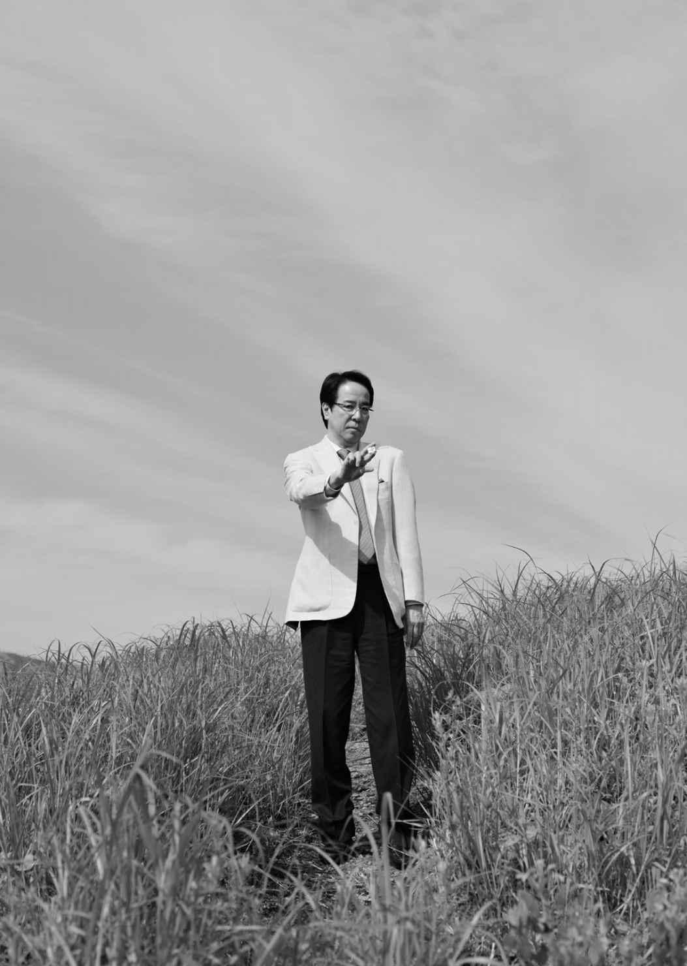

Chapter 1 Noticing Luck.

Classify one's luck

What is "luck"?

According to the Daijirin (Japanese dictionary): "A course of events that is impossible to understand with human knowledge. A happy coincidence. A happy encounter. 2) happy chance to meet someone.

I never had the courage to go to Naritasan to fast, but when I learned about luck, I became very aware of it.

The words "luck" and "fortune" were used to describe the shape of the invisible, which I translated into a "periodic biorhythm" and discussed.

What can you do to grab that biorhythm and turn it on yourself? I thought that the key to this was to be able to feel (or notice) your luck in your skin, and categorized it into the following three main types.

Luck that is inherent in the first place.

Luck that changes from day to day.

The luck of growing your own.

This "natural luck" is a destiny given to you by nature. Therefore, you can't do anything about it by yourself.
However, the other two types of luck depend on how you are aware of them.
Luck, which changes from day to day, begins when you wake up in the morning. If you are not aware of your luck, you will spend the day unaware of it, and as a result, you will lament that you have had a bad day.

There is no room for "judgments" such as, "I feel like I'm having bad luck today, so I'll do this. If you say, "Well, it wasn't my lucky day," it won't even be a reflection, it will just be an impression.

In order to recognize highs and lows of fortune quickly, you need to have the "ingredients" to make a decision. The earlier and more materials you have for judgment, the stronger the basis for your decision, so I began to place importance on what you do immediately after waking up. As soon as you wake up, how do you feel about the scenery and the movement of people around you? This feeling is the criterion for judging high and low luck in daily life.

It's a lucky day when the movement of the landscape and people is accepted naturally without any discomfort. Accepted naturally is an image that fits smoothly into your body without getting stuck. In the beginning, it's okay to just look consciously at the landscape and other people instead of rambling on.

On the other hand, on a low luck day, you will feel some kind of discomfort, as if you are out of rhythm.

If you make it a habit to check your vision quickly after waking up on a regular basis, you will start to notice the difference in how you feel.

Looking at an alarm clock is not enough to narrow your vision. Also, you can't expand your field of view by just looking at the inside of your house. If you can, open a window and look at the scenery outside.

The information that comes in from outside increases the accuracy of how we feel all at once: "The wind is pleasant today," "It's surprisingly humid," "The flowers are starting to bloom," "The birds are flying pleasantly," and so on. How to feel is not common, as each person is unique.

Simple, a day when you can smoothly do what you want to do and love to do is a lucky day. It may be easier to understand if you see a day when you are inhibited in any way from doing what you love to do as a low luck day.

The more you make a habit of doing things after you wake up, the sooner you will be able to feel more and more information to measure the highs and lows of your luck. When this happens, you can make "predictions" and be prepared for every action. If you feel that today is not going to be a good day, you should be aware that your luck is low, for example, "It may not go as well as I expected," or "My luck is low, so I will not do anything unnecessary, and I will just go on with what I have been given. You can

Especially on days when I feel low on luck, I don't even dare to do what I want to do. If it's Mahjong, I won't play a game of Mahjong even if I want to. When it comes to daily life, I want to take on a new challenge, but I don't. You have to be aware of your low fortune and restrain yourself from doing so.

"Self-control" means the suppression of one's emotions and desires and is an ability that only humans are privileged to have.

So you're not lucky, and it's not going to work. The basic idea is to not do anything extra.

Even "words" can bring down your luck. You need to exercise restraint and reduce the amount of words you say. For example, you may want to call that person, but not today. On days when your luck is low, you tend to say unnecessary words.

Nothing is better than being able to predict everything. When you wake up in the morning.

If you are aware of the highs and lows of your luck, which change from day to day, you will be prepared.

If you don't realize it, you will unconsciously do something extra, and as a result, you'll end up saying, "I've had bad luck today.

Personify everything.

You have to cultivate your own luck. This is not a story for today or tomorrow, or for this year or next year. It is a story that will last a lifetime. Cultivate your own luck.

It all starts with this awareness. Anyone can start having awareness anytime, anywhere.

I began to personify everything around me in order to make this awareness a habit.

"Everything has life in it.”

With that in mind, I interacted with things.

In the case of mahjong, for example, there are tiles, a table, a chair and a point guard. The tools essential to the game are material things, but there are always "people" involved in the game who make these tools.

That's why the tools are still alive. How long does it take to make one table, and how many people have gone through a lot of pain and trial and error to make one?

Everything is born with the feelings of its creator. If you are able to feel that feeling, you cannot be rude to things. Furthermore, when there are people who carry things and people who sell them, they can come to you.

It's the same as an athlete taking care of his or her partner's equipment. It is the same with a ballpoint pen or a grain of rice. No matter how insignificant the object, if you can imagine a human being intervening in it, you will have a better understanding of the

The image power expands and enriches the mind.

To cherish things is also an act of not asking for a price. There is neither profit and loss nor calculation. I assure you that if you take care of things, you can become a person who can imagine how people feel as a result.

Also, as you live a self-centered life, your good fortune will come less and less often. Of course, you may be able to break through with your personal abilities, but luck will be less and less of a tailwind. So it's good to be able to do everything above and beyond your abilities.

Know that you are not self-centered, but that you are there for the other person. If you don't make it a conscious habit to give up your selfish desires, it may be difficult to do so. We all have various selfish desires, such as greed for food, money, sex, and career. In order to make this a habit, we need to be conscious of the fact that we are there for the other person in our daily lives.

It's also important not to put things off. This is another important factor in the development of luck.

Do what you can immediately. You can't be impatient, but you must act immediately.

You come home tired and leave your jacket off. I really want to put it on a hanger, but if I want to put it on a hanger instead of doing it later, I'll put it on a hanger first and then start the next action.

In short, luck grows by not taking it easy. That doesn't mean you spend your days like a practicing monk. We have to be conscious of avoiding easy choices as much as possible. We need to act with the awareness of doing what we can do now.

However, if you seek your own luck, you will be calculating and it will be useless. You don't ask for anything. You only think about what you want to do to the other person or thing.

I don't expect results or anything in return at any time. There are plenty of things you can do for someone that they won't appreciate, even if you do it for them

It is. When that happens, you have to accept it with sincerity. If you say, "I'm doing all this, why don't you understand?

You are human and you can't help but think that way, but don't think that way as much as you can. It may have been unnecessary, or it may have been the wrong thing to do.

Luck doesn't grow suddenly. It's the daily accumulation that makes your luck grow.

How to measure the highs and lows of luck

Luck, luck and flow. In mahjong, there is a current debate on the presence or absence of flow, but it has not been proven that there is flow, nor has it been proven that there is no flow. But it has not been proven that there is flow, nor has it been proven that there is no flow.

Although AI (artificial intelligence) has become a hot topic, the analysis of real mahjong is still insufficient. Although analysis of online mahjong games has been advanced, analysis of real mahjong has hardly progressed.

Luck, luck, and flow are unprovable and therefore misleading, and depending on how you receive them, you can feel like you understand mahjong. However, in the end, no one knows anything about it. For professionals pursuing the unprovable, the more they pursue it, the less they understand.

I think mahjong is a never-ending story, and I think that's fine.

I view luck, luck and flow as the same thing. There are highs and lows in luck, and the first thing I do is to know the state of luck I am in.

Specifically, I use the following items as a guideline to measure the highs and lows of my luck while checking each game.

When you're determined to never curl up.

Knowing that I will be Ron.

Deliberately (judging it to be a cheap hand)

When it's totally unexpected

when you're pregnant

“Agari.”

The highest possible form of the hand

When your opponent is reaching out to you.

For some reason, a hand that is finished in Mensing is eaten by a player who has to eat a hand that is finished in Mensing

When two or three sub-dews (making a face by crying)

Immediate Going Out (despite the fact that the tiles can still grow if you are patient)

Reach.

In the highest possible form.

I'm just trying to slow you down.

Goes out with a score not much different from Yamiten

The game is lost because the player reaches for a tile that is in Yami-Ten and is in a losing hand

Rakufu (Richi without a role)

The other family will finish up with you

Firing on another house.

When the game is over.

one player

With the Atari Tile as a handout

No-Ten with the Atari Tile

one-man operation

A win with a missed win

No-Ten after missing a win

Each item is numbered in the order of how to keep your luck going. The farther away the number is from the number, the more luck you'll miss out on. I use this number as a guideline to go on the offensive when the luck is sustained, and when I feel that I missed the luck, I will defend thoroughly.

Many people, both amateurs and professionals, have a vague sense of high and low luck in mahjong.

For example, in many cases, the term "lucky" refers to a state in which the player is able to declare a winning tile in a concealed hand, or is able to easily declare a Tsumo tile in spite of a difficult wait for Kanchan or Penchan, or is able to declare a winning tile in a way that is usually unthinkable.

In order to avoid such vague judgments, I divide the criteria for measuring luck into the following 4 categories: dealt tiles, early game Tsumo, Yi Shanten and Tempai. I check each game and use it to decide whether to move forward or to restrain myself.

Haipai.

[During high spirits]

- Two or more pairs of ryanmen to facilitate the formation of groups
- Pairs with 3 or more isolated pointy tiles (3.7) that are likely to form a double-sided shape are the ones that come before the formation of a group.

[In low spirits]

- There's a penchan
- 2 or more sets of Kanchan forms (2-4, 4-6, 6-8), which are made up of even-numbered tiles.

Penchan from the dealings suggest that the future is uncertain, and if not resolved at an early stage, it should be judged as a sign of bad luck. Kanchan is also a form of even-numbered tiles, but without the Tanyao Odd Tiles, so it should be noted that Kanchan is also unstable.

Early draws.

[During high spirits]
- In the early rounds (1st to 6th round), tsumo kanchan or the penchan tile and tsumo kanchan tiles 3 and 7, and tsumo kanchan tiles 4 and 6.
- 3.7 with 2 to 3 Tsumo cards

[In low spirits]

- Not a single tile in the early stages of the game is unsuccessful.

- I can't draw a single 3.7.

Even if a tile looks like it can be easily won, if the hand does not draw a kick-start tile in the early stage that can be used for pinfu or double-sided hand, it should be judged to be unlucky.

Iishanten.

[During high spirits]

- Within 1 or 2 rounds from iishanten to Tenpai

[When your luck is flat]

- Three to five rounds from iishanten to Tenpai

[In low spirits]

- More than 6 rounds from iishanten to Tenpai

Iishanten is a hand that can be ready to start a hand when one more tile is needed. And if you go beyond the limit of 6 rounds, it's obvious that you are not in luck and it's not safe to move forward any further.

Tenpai.
[During high spirits]
- Ready to play with a completed role
- Tenpai with an odd number of Tan Yao tiles, drawing a tenpai dora

[In low spirits]

- A cheap one is in and the game is ready to go.

- A hand with a collapsed hand

- The one with the worst shape is left as a handout

When you get a "tenpai," you feel relieved. Then the desire to get promoted or to get promoted starts to swirl.

In fact, this is a major pitfall, and I can hear the lamentations of those who would not have friended in if they hadn't been tempai.

The way a hand enters tempi is an important factor in measuring your luck. You need to be careful when you get unwanted "tempi" such as a low point or a collapsed hand. You should take a "wait-and-see" approach with the strategy of not taking a hand, not to mention Reach.
On the other hand, when you get a satisfactory "Tenpai" hand, you don't hesitate to play riichi.

Method of restoring one's fortune

Luck is a fickle creature.

Even when you are "fit" to be yourself, you don't sit still.

The movement will be sensitive to each stroke that the batter makes, so you want to make sure you don't let them make unfounded and unnatural movements.

If you feel your luck starting to drop, you can hit that low state of luck. That's all it takes to say, "Oh no, I'm not getting lucky! And you'll spend less time lamenting, and you'll have fewer ups and downs and more results.
When the luck is low, Tsumo tends to lead the player astray. This means that it is easy to understand, such as tanyao, pinfu and tricolor.

A hand that has a number of points is unlikely to be fulfilled.

It's about striking to the height of your body.

Since your luck is low, you will never get what you want. You might be able to get to tenpai, but it's unlikely to lead to agari.

When your luck is down, there is a tendency for tsumo to be played with more end tiles, or for tows to form and not tsumo to be played. On the other hand, if you can take advantage of this tendency, you'll be freed from what is commonly known as a slump.

And when you feel low, you can't just go ahead and hit it the same way you did when you were feeling lucky, but the end result will be different and less than you hoped it would be.

However, we must not forget the reality that we can only find a way to make use of that unpleasant form (the fact that our luck is low).

As is the case in most cases, the beautiful final form you envision (wa-ryo) will not become a reality unless luck is in your favor.

Everyone's "Manchurian! Jumpman! Double time! I play with the hope that the result of the game will be a positive one. However, the gap between ideal and reality needs to be viewed as an everyday occurrence in mahjong and it is important to be honest with the luck that is available to you. This is why you need to create a hand that matches the luck you have.

Particularly during low-luck periods, you should think about going out with an awkward shape, using Fung Tile.

Here's why I see "chanters" or "pure chanters" as a catalyst for the recovery of luck.

You don't need to be concerned about mensuration, and you can consider the biting chanter to be sufficient.

'With these hands!' !" and then there comes a time when you have to blurt out more.

If you feel your luck is low, you need to accept the situation you are in, change your mind, and strike.

One shot! Instead of fumbling around with things like, "I'm not sure if I'm going to be able to do this," we can embrace our low luck and prepare for recovery.

Change the procedure and change your luck.

By changing the procedure, the flow of luck can change.

Changing the procedure means changing the order of "how to get in" and "how to get out". Instead of changing the content of the routine, you have to change the order of the routines, and you have to change the order of the "how to get in" and "how to get out".

When your luck is low, routines often don't work, so simply changing the order of how you enter and exit can change the flow of your luck.

I have the following order of routine for cutting tiles (*assuming all field conditions are flat).

When you are feeling lucky / The order of cutting the tiles

- East to South to West to North.
- White to Hatsu to Chun
- When you feel high in luck/ Sequential Order of a Number Tile manzu→pinzu→souzo
- From small numbers to large numbers.

When you feel low in luck/ Sequential order of cutting the tiles

- North -> West -> South -> East
- Chun -> Hatsu -> White
- When you feel low in luck/ Sequential Order of Suit Tile] Suozo → pinzu → manzu
- From big numbers to small numbers.

As you can see, the way in and the way out changes according to the highs and lows of your luck.

You can change the procedure in your daily life as well. For example, on your way to work, get off at one stop in front of the station and walk to work. For example, when you go to work, get off in front of the station and walk to work. This is one of the easiest ways to change the flow of luck. If you feel your luck is low, redecorate your house, or if you are in the habit of eating dinner after taking a bath, simply change the order of your house and take a bath after eating dinner.

In order to do this, you need to start by understanding your procedures.

"This is a basic daily procedure. No matter what you do, everyone should have their own procedures for how they spend their weekdays and holidays. Organize your unconscious procedures, recognize them, and then try to change them.

Set your alarm clock 10 minutes earlier than usual. Take a bath in the morning instead of at night. Review your clothes and neckties and try on something you haven't been wearing before. This alone will change your mood and your luck.

Some companies have morning meetings, etc., but this is another action that changes the procedure. They are trying to attract good luck by changing their procedures.

Since living things grow on the power of the sun, they tend to be more cheerful topics of conversation when it's light. If the lights are dark, for some reason they talk in a whispered voice.
You don't have to stop the natural flow, you have to go with the natural flow.

The same is true for mahjong. We have to take the notion that both release of guns and agari happen naturally.

If you don't do this, you will lose the essence of what mahjong is all about. The essence of mahjong is to cherish the nature of the game. Letting go of a gun is not a good thing.

Reducing the number of points is a bad idea.

This is just a fixed concept. Beginning mahjong players who start playing without such fixed concepts can play freely. When they are called Ron, they say, "Oh, yes. When they are called RON, they just say "Oh, it's so expensive" and hand over the dotted stick. If you think like that from the beginning, you don't have to think, "I'll just avoid shooting.

Talking about "preventing loss of points to get the top spot" will only lead to a smaller scale and a narrower mahjong experience. When players begin to worry about their grades, the thought of "getting the top spot at all costs" or "making sure I don't draw rus" is the biggest negative factor for mahjong.

Grading just happens to be a number at the time, and if you are distracted by such a number, there is a danger that you won't know how to have fun or even the essence of why you are playing mahjong.

Affirming mistakes.

As I watched the video of the game, I thought to myself, "What? Why are you turning that off? It's not crazy! Have you ever thought about it?

As long as you are positive about things, your luck will not leave you. But if you say "no" and deny something, your luck will leave in that moment.

You have to look at it in a positive light and say, "That's the way it's supposed to be cut. You can't just say, "No, it's not.

'What?!' !" often happens to me too, so I try to restrain myself from denying it. When you deny what the other person is saying, there is a measure of yourself involved. It is strange to deny the other person by your own measure. The other person is talking with what he or she thinks is right. To deny that is to say, "Who are you? That's what I mean. It would be funny if you didn't ask, "I guess that happens.

If you don't make it a habit to see things in a positive light, not only when you're talking, but also when you're looking, you'll be more likely to get out of luck.

Complaining and criticizing will keep your luck away. The God of luck will not protect such people. From the God of luck's point of view, "Are you that great? And they think, "Well, you'll have to do it alone then! That's what they say.
Nothing comes from denial.
Everything comes from a place of affirmation.
In any sport, there are people who win in mysterious ways. Why that guy? Instead of denying, "What is it about that person that makes him/her so attractive?", we affirm, "What is it about him/her that makes him/her so attractive?", and then we look for the factors that make him/her victorious. That person must have been chosen by the god of luck because he or she has some kind of attraction, and as a result, must have won.

The same is true for games. Affirmation in a game means respect for your opponent. When we play with respect for each other, we develop empathy and sensitivity. The tiles grow in an interesting way, and the content of the game becomes more substantial.

What the fuck is this? A game is never good if even one person is playing while thinking, "Oh, no! Chi again! If even one person thinks, "What a loss of quality! Those who play with this in mind think that the person who played Chi has disturbed the place. This is not true. It is the person who disrupts the scene.

Some professionals are not afraid to say, "I lost because it didn't develop well.

This is an excuse for the harm that has happened against you. This is also the very reason why you are the cause of the problem. It is the mind of the person making the excuse that makes the game worse. It is your own mind that is making the development worse, and you should reflect on your attitude towards the game, saying, "My attitude towards the game was bad. The awareness of blaming others itself creates bad sympathy and causes things to happen that you think are detrimental to you.

Even if the other person is inexperienced, it can often work in your favor and bring about a positive outcome, so it's a mutual thing.

Even if someone is in the early stages of his or her career, I'm not sure if I'd like to give them a deal that would not be lost.

You're bothering me again! That's why the "spirit" is the same.

This is when the flow of chi is slowed down and things start to happen that you think are detrimental to you. If you can help the player think, "I wish I had a tile that was easy to understand," it will help bring in good luck.

The same is true for your actions, you can affirm what happened. Miss! It's a denial to yourself, "I did this, now I'll do this. You've done it, so now you can do it.

A cycle of mistakes is caused by a cycle of denial. Everyone makes mistakes, and it's not a big deal. No one can play mahjong without making a mistake. You make a lot of mistakes that are invisible to the eye. Nevertheless, once you deny yourself, you may end up dragging yourself down and even ending the day with your mistakes.

You can affirm yourself, even if you feel like a failure, and then you can figure out how to deal with it next. You just need to change your mind in a positive way to see what you can do next.
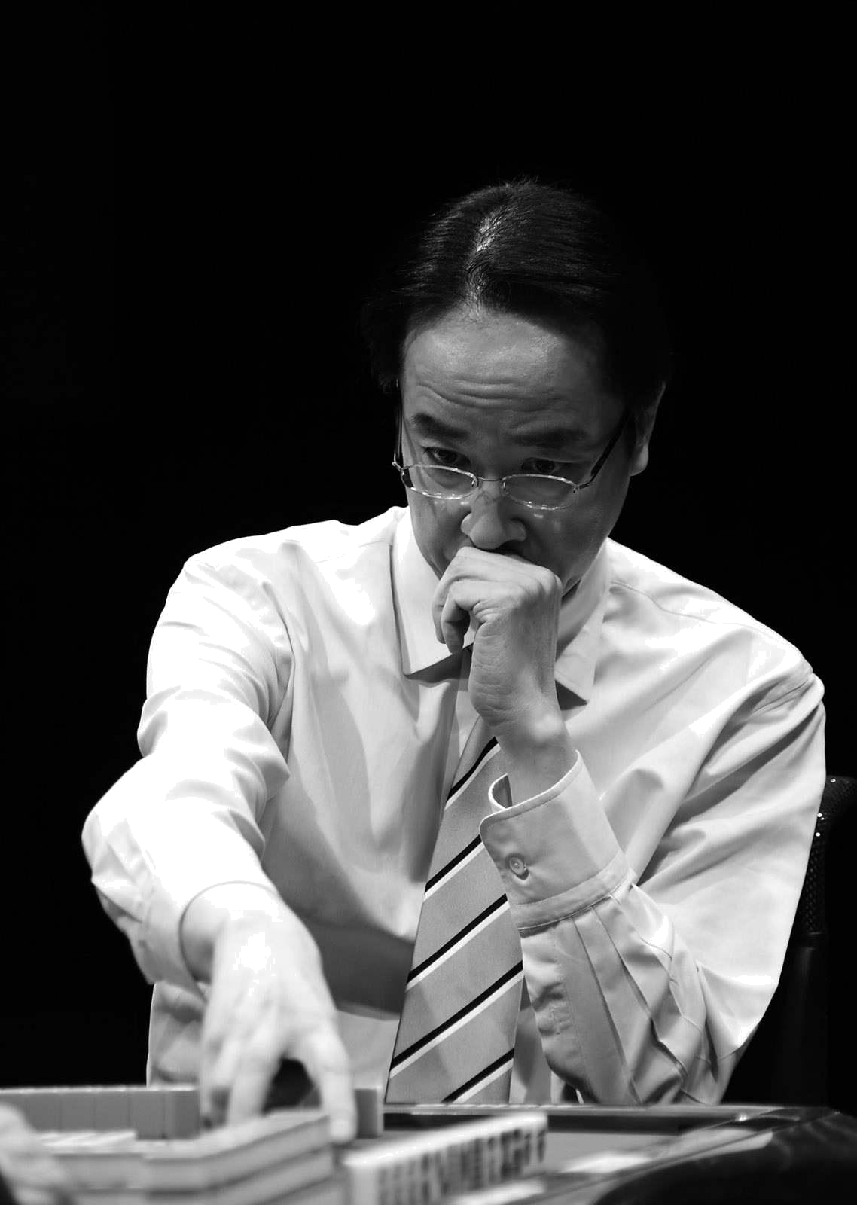

Chapter II. Growing Luck.

Write down the person you don't want to admit to.

Based on data collection and analysis, only efficiency and probability were pursued. 20 generation.
If I won, I was an official army and if I lost, I was a bandit. I was just trying to win, so I had the worst attitude as a person when I was playing mahjong.

As those of you who sat at the table with me in those days know very well, I would come to the table with my emotions out in the open and if someone did something I didn't like, I would fight back by doubling down on them. There were many times when I acted in a way that intimidated my opponent.

And he has a short temper, so he loses his temper easily. Because of his human immaturity to get angry at his opponents, he will say, "Why would you cut those tiles! What a fine thing to say. No matter what happens, it's someone else's fault. He played the victim, saying it wasn't his fault. They were hitting me with their attitudes, frowning, and even saying things like, "It's not my fault.

If the loser is frustrated and complaining about it, it's fine, but he's winning and he's taking it out on them. But it was a shameful thing for him to do, because he was on a winning team and he was taking it out on them, complaining about it all the time. "What the hell is he doing?! There is no doubt that they thought it was a good idea.

And because he was winning, he never thought about the feelings of those who lost.

It was really stupid.

One of my many weaknesses and flaws is my perfectionism. If I was imperfect and demanded perfection from my opponent, the game would inevitably collapse.

I was the cause of it, and I was like, "Why did you disrupt the scene! And a young man in his 20's looks up to the top of his game in a big way. I don't ask for it for people I respect.

But I've been asking for it from people who didn't feel that way.

I was a really ugly hitter until I was in my early 30's because I hadn't fundamentally improved after I went pro. I once snapped at a pro who was thinking long and hard. 'Huh?' What a twist of the neck!

I was once warned by a senior professional for such an unseemly attitude.

He scolded me seriously, "You can't act like that.

Such a shameful player could never change the image of mahjong. When I was promoted to the Japan Professional Mahjong League A1, I began to seriously work on improving my weak points.

I decided that the only way to improve my week points was to write them down, so I started writing down all my week points, from how to play mahjong to my daily life, in a notebook. A diary would have been too much for me, so I wrote them down once a week in my university notebook.

When I actually wrote it down, I found myself one after another that I didn't want to admit, so I made bullet points in the vertical column. In the horizontal column, I put the date of the first time I wrote it down, and when I tried to improve or improve, I added the date and wrote down how I improved, what led to the improvement, and what kind of improvement it was.

This note became my weekpoint calendar. Things like, "I was able to improve in July 2010," "I went back in October," and "A movie I saw in November helped me improve.

We sorted out the week points once a week and became aware of them as we recorded them.

It's what you don't want to admit that you write down and accept. Self-awareness was the first step to overcoming my week points.
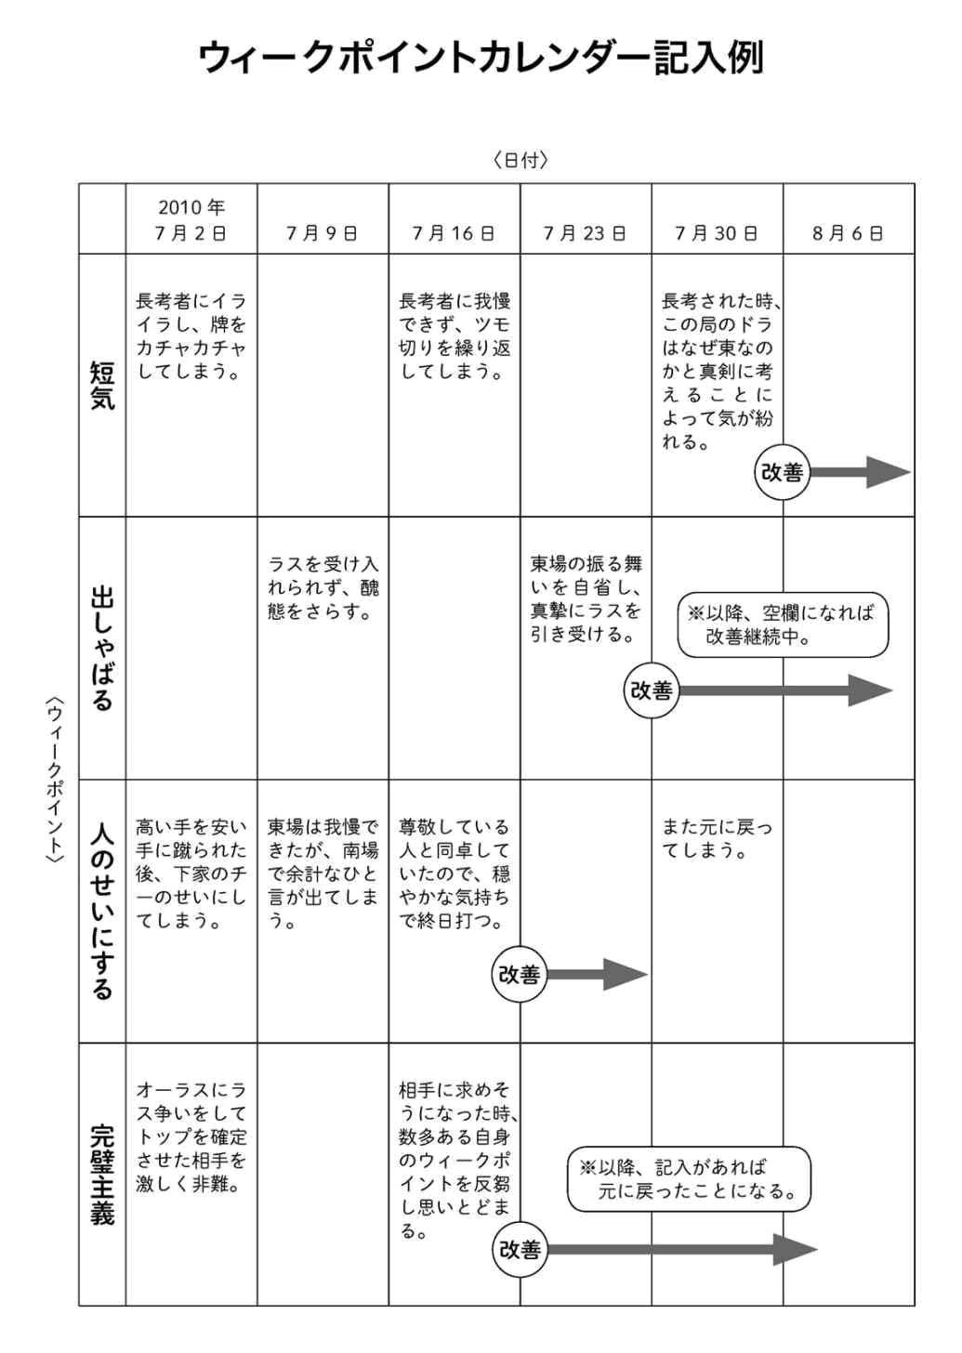

How to fix your mind when it's disturbed.

One of the weakpoints I didn't want to admit was my temper.

Although I was aware of my temper, I was often hitting for long periods of time, so once my mind was distracted, my mind went blank, at least during that game, and it was impossible to correct it. Everything was either riichi or Chi Pong right away, and it was hard to correct.

I know the moments when I get mad.

It feels like some of the nerves I was controlling are snapping and I think, "No, no, no," but I can't control it.

To be honest, even now that I'm in my 50s, I still find myself in that situation from time to time.

However, by writing it out in a notebook, the speed of the repair process has been much faster.

About three rounds would be ideal, but now I can almost always repair it within six rounds. Compared to the old days when I couldn't repair a car all day long, the fact that I've been able to shorten the time to 6 rounds or less is probably due to the accumulation of my age and career.

In my experience, when young people lose their temper, it's best not to try to force them to rebuild.

It's better to expose yourself to the limits of how bad you can be.
In this case, you don't put the brakes on and expose yourself completely. And then check how far you have exposed yourself. This recognition is the first big step towards self-awareness. If you add or subtract in a poor way, the recognition.

There is a danger that you will be halfway through and you won't know where to fix it.

Today, I'm going to lay bare! You think it's about as simple as that, and use the time of one game or one day to expose your ugly side. Once you start getting angry, your opponent will gradually stop touching you. But if you can say, "I'm sorry about today," after the game is over for a day, it's okay.

It is impossible to admit your own fault because you are so pretty. Once you can tell them you're sorry, you're in a position to improve. I'm not mad! Then it will never be fixed. This could cause you to lose your temper again very quickly.

'I could have lost my temper, but I didn't leave today.

It would be great if I could say at least "I am relieved.

It was hard for me to say. I didn't want to admit that I was in the wrong. I tried to put it in the past tense that I just happened to be that way. This is not the way to improve. First of all, I have to admit my faults. If you do so, the other person will accept you.

"You're right. You've got a bad attitude," and you've already started to improve.

I had never thought about how I felt about the losers, but the weekpoint calendar helped me to understand the transition of the losers' minds.

I became more and more aware of my feelings. And I became more and more able to consider those feelings.

As I learned to be more attuned to my opponent's feelings, the number of emotional hitting tiles that had been common before decreased quickly.

Emotional striking means that when things start to go wrong, you lose patience and play wildly. The feeling is disturbed, thinking becomes a chore, and the player cuts anything, even Dora. On the other hand, if a player has a point stick
When the player was playing in the game, he would look up and say, "See if I can make it. That's the ugly part of my mind that I couldn't even look at, but it stopped appearing on the table.

Because I was able to admit my shameful weaknesses and shortcomings, I was also able to teach and advise people who were disturbed about how to fix them.

Be aware of your own weaknesses.

This was another point of playing mahjong.

I feel that my continued playing of mahjong has helped me to correct this a bit.

Open your mind and open your way.

To strengthen your ability to feel your luck, you need to learn about the world you don't know.

It can be anything that you don't know. You just need to be interested in what you don't know.

When you go to a bookstore, for example, there are lots of books about the world that you don't know about. You don't just pick them up; you read them. For example, if you go to a bookstore, don't just pick it up; read it anyway. If you like to travel, go somewhere you've never been before. If you go somewhere you don't know anything about, you'll feel something.

Whether you're interested or not, you're going to take action to learn what you don't know.

It's okay to watch a TV show that you don't normally watch for 30 minutes. It's okay to watch it because you don't really understand it. As you watch, you will feel something. It doesn't matter what you feel. This will give you a new way of feeling, and that will help you to improve your sensitivity. Anyway, you have to be curious.

In order to do so, you must always keep an open mind. There are always good things about human beings. You have to develop the habit of respecting those strengths.

We all have our weaknesses. You can't fix your weaknesses by telling someone to fix them. It's a weakness, and you have to accept it before you can deal with it.
It's the people you think you don't like or aren't good at that you should try to find the good in them. If you do this, you will always find a good point. You may think there is only one good point, but there are many. You can't see them because you don't want to, but if you try, you'll see them.

If you close your mind, you can't feel or notice. Even in the midst of being told something you don't like or don't want to hear, this person's presence

You have to look for where your cousin is. There will always be strengths. That way, you'll have less of a bad impression of the other person and you'll be less likely to dislike them.

I don't like what's being said, but I don't dislike the person themselves. Becoming able to think like that will help you to improve your sensitivity.

We are human and we can get angry at times. Even when you are angry, if you remember the strengths of the other person, you can change the way you listen to what is being said.

The other person also has an awareness of you. If you open your heart, the other person will surely notice and change their impression of you.

If your impressions change, your responses will change. If the response changes, the path will be clearer.

The same is true even if the relationship is acrimonious. And the reason for the bad relationship is that you are the cause of the bad relationship. The other person does not create it. It's all about how you feel about it. You are not the victim; you are the aggressor. Because you are not aware of yourself, your relationship with the other person is strained.

Even when you are playing mahjong, when your awareness of your three opponents is not good, things tend to happen against you. This is because the aura of awareness you emit is transmitted to your opponents. And yet, if you are not aware of your opponents'
I'm going to do it.

Sometimes I think, "I'm losing my agari because you're faking it," or "Why do you have to be so outspoken? But that's because you're making yourself do it. Your poor awareness is transmitted to the other person.

Look down on yourself.

Once I became more conscious of cultivating my luck, my results increased dramatically.

One of the factors was that I was able to get a bird's eye view of myself. It's as if another me is pulling a camera and seeing the situation I'm in from above.

This feeling can be acquired by anyone with training. I was blessed to have a teacher. Even if the tiles are tight, they can wrap the whole table

There was a warmth of the game. But if you don't have the heart to feel that warmth, all you can see is a superficial, hard playing tile. If you don't have the heart to feel the warmth, you can only see a superficially harsh tile.

It is not uncommon for me to get caught up in a busy schedule, or when I am too busy with my work, to be blinded by the events in front of me, and not be able to see the whole picture.

To maintain the awareness that you can look down on yourself, "posture" is important. In the case of mahjong, you can maintain a posture away from the tiles to get a bird's eye view of the game.

You will be able to do this. Consciously move away from the tiles.

After all, the tiles are an illusion.

You don't have to be attached to an illusion.

When you become focused, your body will subconsciously get closer to you. If your body gets all the way in, you won't be able to look around. If you feel like you're about to move forward, you consciously move away from the tiles. The stronger you want to get in, the harder it is to get in.
The desire to be aggravated is already selfish. You may or may not be able to get aggravated. You have to be flat to be able to think that way at any time.

It may work, it may not. That's the kind of mind-set you should have. Then your worries will disappear and you will be able to see objectively.

But passion is necessary. Passion is a strong feeling for the nature of things. Always have a strong feeling for mahjong. It is a passion for mahjong, not for the tiles, but for the game.

When you learn to look over the game, you will not want to aggravate it because you have made it this far, but you will feel that the tiles are an illusion that cannot be relied upon at all, and that they will disappear after all. It's not something you can decide for yourself. Once you have completed one more step, God knows what else. It's wonderful to have completed it to that point. You have been able to communicate your strongest feelings to the tiles. That's all you need to do. There is no need to seek results.

No, it is not a good thing that we have 14 cards.

The process is important, and if you get a lot of energy beyond that, you're going to be focused in a different direction.

It's not a good thing to think, "Why wasn't I able to get an arrow when I had such a good wait? It's not so much a question of whether or not you're able to get an arrow, as it is of whether or not you're able to get an arrow.

When you can take care of the process and get a bird's eye view of yourself, things will work out for you as a result. There may be temporary troubles and hurdles, but in the end, things will work out. That's why we can live.

Philosophy of the east and south fields

In Mahjong, there is a unit called a "place" and a place is composed of multiple units called "stations".

Originally, the game was played from East to North. Originally, the game was played from East to North, but since the game took longer, the game is now played from East to South.

The mainstream is the halfway house in

I make a distinction between east and south markets and proceed based on the "big picture" view of each. The big picture view means the view or judgment on the overall situation and outcome of things. It is necessary to separate "the phase of growing the tiles towards the ideal" and "the phase of playing efficiently in order to get close to the aggravation".

First of all, the east round started at the beginning of the game. At the beginning of the opening game (East 1st Round to East 3rd Round), if the game is played with the sole purpose of making a win, even if it leads to an easy win, the player will have a hard time in the later games. "Let's just play one game for now.

I think we'd all be better off just getting ahead of ourselves.

Such easy thoughts should be discarded. You should discourage yourself from giving up the tremendous benefits that the Mahjong Gods have given you that day.

I want you to make a vow not to choose the cheapest possible moves in order to check your luck on a day that will never come again.

Even if there is a breakthrough that could lead to a higher handicap, if there is a breakthrough that could lead to a higher handicap, I would like you to challenge your own potential, with importance on the direction that could lead to the breakthrough. That's why I'm sure you'll be able to find a solution

It doesn't matter if the rate drops dramatically.

Especially the first game of east is very important. I think about what I am getting from the god of mahjong on that day. While carefully savoring the feeling, I let go of the desire to go out of the game and play towards the ideal form.

In doing so, don't be distracted by what's happening around you. Don't be distracted by the phenomena you see, such as your parent's riichi, Dora's pong, or chin-tzu moves. People are people and you are you. By keeping this spirit in mind, you will be able to confirm your natural luck.

Therefore, "I'm sorry you had to do that because you got a tsumo," or "I'm sorry it was so cheap. You should refrain from accepting the point stick by asking for the other player's agreement.

Not that this is a bad behavior, but I would like to avoid such self-protective agali as much as possible.

The very act of taking a trivial immediate tenpai is the very weakness of human beings.

When you're trying to build something, you only use the materials in front of you

entirely

If you make it by doing so, the slightest shock can cause it to fall apart in a fragile manner. If you go to pick up the immediate agari, you'll get bad bacteria in your hands, and you'll be left to struggle afterwards. It doesn't matter how fresh the ingredients are, a little extra effort is just as important to enhance the flavor as it is to enhance the taste.

In order to avoid boring Tempai, you don't have to play boring "steps". This is an important point in the Opening Philosophy. It doesn't matter if you can get a win or not, it's secondary.

After the East Market, there are five points to remember when approaching the South Market, which is the middle to the end of the day.
A look back at the progress of the east field

Evaluate your own state of luck on three levels: high, medium, and low. The first aggravation you aim for in the south field is to match the high, medium, and low states.

When there are two games left, only an aggravation that will allow you to move up one place or keep your origin in mind.

When you can't do anything (when there is a big negative impact), don't muddle your way through.
Being mindful of the importance of mahjong is also an important part of the game. This translates into respect for one's opponent. Only by controlling any emotion, any fear, any selfishness. Only through restraint of these will the knowledge be achieved and the dignity of the player be preserved.

However, this knowledge should never be forced on anyone. It should only be shared by the batsmen who decide that it is the right thing to do, and should not be subject to criticism based on standards of right and wrong.

Encourage patiently.

"Creation" is mahjong and "destruction" is also mahjong.

Often you don't know what to do with a given form until you try to break it once. The reason why it doesn't work is because you try to do something with the form without destroying it. If you think about what happens when you create a game after destroying the tiles and procedures, you will discover something new.

In particular, I have had repeated experiences of creation and destruction in mahjong classes. Even though I tried to explain the game in a very thorough manner, my beginner students could not understand me at all. At first I felt frustrated and asked "Why can't you understand me? I've been thinking about it for a while now.

One day, a student told me.

I have no idea what they say, because I've never heard them before.

You are exactly right. The birthplace of mahjong is China. There are a lot of unfamiliar Chinese words in mahjong terminology and it is hard to imagine. I have to replace those unfamiliar words with words that are easy for students to imagine or to touch the heartstrings to convey the message.

For example, a phoenix is carved on one of the Suozi tiles, but it is difficult for a beginner to recognize it as one of the Suozi tiles. Because of the shape of carved tiles, some people think it is one of the letter tiles. If so, how to explain it? It is said to be a mythical bird called the phoenix, and there is a theory that it is the god of mahjong.

Changing our cuts is also a kind of disruption. We need to break the way we've been doing things and reset and rethink the way we've been doing things.
But even if you can get the message across, whether or not they can put it into practice is another matter.

From there, you need to be patient and encouraging, because there will be a long period of time when you know but can't do it. It's important to be positive and encouraging, saying, "Let's learn to do it," and "There are many things we can't apply well yet, but we'll be able to do it." and to be willing to walk with them.

It will be a good idea to Sometimes it may be necessary to replace it with something more imaginable to suit the person's tastes and preferences.

No matter how many times I say it, they don't get it. The work you asked for doesn't come up to your image. It's all your fault if the truth of your words doesn't come through.

It's not a matter of "he's not listening" or "he's not learning enough". It's not because he doesn't listen, or because he doesn't learn enough, but because he doesn't have a true intention in front of him.

What is the backbone of the story in order to convey the truth? We need to keep trying to communicate the root of the reasoning. If people don't understand the root of the story, they will go on and on in the wrong direction, so we have to be willing to put in the effort to communicate the pillars of the root of the story, not the ends of words or individual branches and leaves.

Why do we have to do this?

What's the reason we need to work on it?

And what's beyond that?

If you can get the root of the message across, they will be naturally motivated.

Predictions are everything.

Predicting is a very important prerequisite for "cultivating your luck.

In mahjong, a player is a professional when he or she anticipates and anticipates everything that may happen during a game.

Therefore, "long thinking" is the flip side of being unpredictable. In both basketball and the world of golf, "slow play" is even penalized.

In the case of mahjong, except for amateurs, the long view of the professionals is a problem that needs to be improved.

Some pros think that if you are in a tournament with a 50-minute time limit and you are in a long game, if you are at the top of the leaderboard, people will think you are stalling for time. It may be misunderstood as a strategy.

'If you don't check, you're going to miss something, and you'll have to take the time to think about it to come to a good conclusion.

There are some professionals who claim those kinds of rights without hesitation, but there is a big difference between "thinking" and "wondering". It is natural for a professional to check every aspect of the game before your turn to play Tsumo.

Many professionals worry and groan after the reach is applied, but as a professional, it's only natural to anticipate the reach.
Also, if you get a double reach, there is much less to think about. It's as pathetic as the way you're freaking out about not flipping into a double reach.
There is no such thing. You don't know immediately what the waiting tile for double-reach is, so you have to assume that it's inevitable if it hits.
Professionals are only professionals when they live in a sharpened world, so they need to make quick decisions.

People who are slow to make decisions are not professionals.

The long view is not good entertainment. A game with a poor rhythm in baseball, golf, football, or any other sport is not worthy of being paid to be watched by an audience, nor does it produce a great game.

The game is one piece of work, so it needs to be shown in a flowing way.

Particularly in games between professionals, if you don't have the feeling that you're trying to create a good game for each other, it will hinder the game in terms of time and sensation, which will only cause stress for the viewer.

I'm aware that my decision-making skills are getting slower and slower with each passing year, and I think that's what I'm doing with my self-discipline.

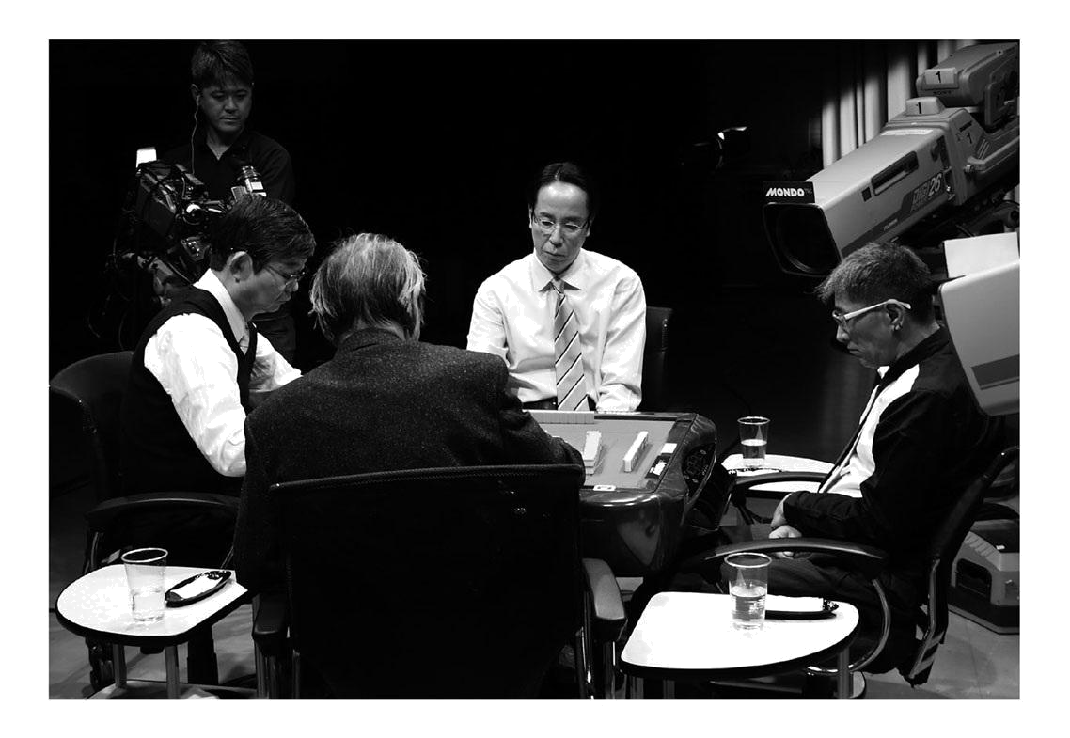

Value your intuition.

One of the questions we are often asked is when to reach . Reach is the act of declaring a hand in Mensing, but only in case of Tenpai.

A yaku yaku that can be completed. Judgments vary depending on the situation, such as "place," "station," and "point in possession," but the answer to this question is, "When you want to play riichi, it is the right time to do so.

The reason for this is that we are animals too.

Animals live by "sense". They become human because they have "reason", but most of the things they think in terms of "reason" prevent them from having "sense".

Let's wait for a change of hands and then reach.

'He's a parent, so let's reach out and hold him down.

'The first round is slow, so let's not do any riots.

"Rather than suppressing sense, it's better to be an animal that lets loose our senses. , you will be less likely to regret your decision. Therefore, when you want to reach, it is the right time to reach.

The reaching role is also an act of retreat. It's also an act that temporarily stops you from thinking, so you need to know more about the act that is driving your luck. I have three taboo-reaching theories to help clarify the criteria I'm willing to reach for.

[Three Principles of Taboo Reach]

- Do not use "pinfu only" riichi under any circumstances, except in cases where the top reversal is possible on the auras.
- In East Round, you must not play Nomi Hand Reach with a head on the top of the head, even if the wait is in a 3-men formation.
- Except in a desperate situation where your luck is faltering and you can't pull out any more, a hand with a low point and a winning tile must not be reached immediately.

Just by following these three points, the number of wasted reach sticks should be drastically reduced.
Wasted reach is a reach that doesn't lead to later on.

Mahjong is a game that is played with a "line" rather than a "point". If you chase after your opponent's goal of just winning the game in each round, you'll be strangled as the auras gets closer and you won't be able to win even if you want to.

Humans are weak, and when there is a prey hanging in front of us that is ready to be eaten, we can't help but get out of it. We have to remember that this action can have a negative effect on our bodies later on.

You're so caught up in your loss that you lose everything

In 1996, ten years after he became a professional, he decided to manage a dojo, which was one of the ten pillars of his professional activities.

Why the Dojo? As a karate student in high school, I thought that mahjong had its own path to follow as a striker.

"Dojo" means "a place to practice martial arts. It also means "a place to train the body and mind broadly". He felt that a place to train and strengthen physical strength, mental strength and ability was necessary for mahjong as well as martial arts, and this was the reason why he opened "Mahjong Dream Dojo", a healthy mahjong salon in Sapporo. That was the reason for the opening of the Mahjong Dream Dojo, a healthy mahjong salon in Sapporo. He realized that if you have a strong heart, your dreams can come true, so he named the dojo "Yume" in front of it.

Twenty-five automatic mahjong tables in a space of about 2.5 square meters. It was quite a reckless decision.

Even if you don't make sales right away, it will eventually work out. Success and failure are only born from challenges. When I tried to convince myself that this was the case, I was supported by the kind-hearted staff. Every staff member was hopeful about creating a space where they could pour their love and affection into, and they were all looking for new challenges.

When we opened, everything was going well, including the women's classes, health mahjong, and set rental tables. The staff served customers with an open mind, saying "We are so happy to have you here. On weekends, we also functioned as a venue for competitive mahjong tournaments. As a place for lifelong learning
"as a place to enjoy communicating.”

"as a serious challenge.”

A community was born and nurtured according to individual needs, and a sense of unity was created for all who gathered in the space.

When things are going well, good things are bound to happen. I received an offer to appear on Fuji Television's late night program "The Wareme de Pon Live Special".

Since 1995, "The Wareme de Pon Live Special" has been broadcast on Fuji Television Network and features famous entertainers and athletes who aim to be the strongest players in the entertainment industry.

The prize money at that time was 1 million yen. Until then, the only mahjong professional who had appeared in a game in the past was Mr. Takeo Kojima, aka Mr. Mahjong. Later, in 1997, I happened to win the title of the strongest player in the tournament, and I was given the opportunity to appear in the tournament.

The third time I participated in the tournament, I was able to win, and I displayed a sign with a prize of one million yen at the Dream Dojo and went on a hot spring trip with my students.

However, there is a later story about this win.

The intention of casting me was not to show a seamless and severe mahjong game as a professional, but to show a fascinating way to play as a professional. I thought I understood that intention until the second time I appeared in the studio. However, when I entered the studio for the third time, I misunderstood the true meaning of the words that were casually spoken to me by the program producer.

It's not easy to win.

I took these words with the nuance that if you're a professional, you deserve to win.

I switch to combat mode, aggravating as much as I can, and then silently wait for time to pass. I feel like someone is about to follow me.

When the game is played, it is played quickly with a cheap hand. Mahjong, which is far removed from entertainment, is presented to everyone across the country. To the viewers who stayed up all night wondering who would win, there is no doubt that they saw the game as a mass of selfishness that just wanted to get upset.

Mahjong alone, with no sense of building a game with four players. It was only two months after the victory that he realized that this was a shallow and greedy state of affairs.

"Your mahjong was terrible the other day. I won't have any more professional mahjong players in the future.

It wasn't until the producer told me that I realized how stupid I was.

dimwit

He was a pathetic, miserable professional who was consumed by short-term profit and loss.

What I'm trying to do to prepare for the game

Whether it's a long and competitive league game or a short game like a TV game, there are two things I keep in mind when I'm approaching a game.

The first is to be conscious and calm in your daily life.

As I cope with daily events, I try to spend time with an image of being grounded in order to avoid any fluffiness in the way I place my mind as I deal with them.

I'm very impatient, so I try to be aware of this about 10 days before the game so that I can adjust my life to deal with everything calmly.

The second is to look at the sky more than usual. It's like looking at nature.

It's hard to maintain peace of mind when you're living in a man-made structure, so I try to look at the sky as much as I can, day and night, even when I'm in the city center, to keep my mind in check.

I started doing these two habits after I was 40 years old. This has helped me to have an unprecedented bout of banging.

In the title fight, the 26th O-ranking (2000), 22nd Houou-ranking (2005), 22nd J-dan (2005), 23rd J-dan (2006)

(2006). He also won the titles of "The 3rd Mondo 21 Cup" (2002), "The 7th Mondo 21 Cup" (2006), "The 4th Mondo 21 Championship" (2006), and "The 8th Mondo 21 Cup" (2007) on the SKY PerfecTV channel MONDO TV.
At the same time, a change had begun to occur in my mind.
The praise for winning titles no longer made my heart flutter. On the contrary, it was getting emptier and emptier, inversely proportional to the number of titles won.

As long as you don't reach the level of achievement you are trying to achieve, you won't feel a sense of accomplishment. This is because I realized that even if you win a title, it's important to know what to look forward to afterwards. Until then, winning a title was one of my goals, so I wasn't aware of it. What is the purpose of playing mahjong?
The reality is that we seem to be getting closer to its essence, but not at all.

As a result, they just happened to be winning.

So, what is not a fluke is the "battle with your inner self". That's not a fluke, and there must be a possibility of winning it.

I want to have as many games as possible to overcome my inner self, not just the titles I happen to have won without being able to win the battle with my inner self.

The only game in which I was able to overcome my inner self was the 23rd judan which was my 2nd consecutive victory.

At that time, my mind was full of life. My mental preparation for the game, and the way I put my mind during the game, was unlike anything I had ever experienced before.

Although I was grateful for the presence of my fellow players at the table, I was able to play the game without a single mental movement toward my opponent. My mind was able to look ahead and play the way I wanted to express myself.

It was a title game where I was able to play mahjong away from my ego to win, away from the probability theory of numbers, and with an awareness of mahjong as a work of art. It was the only game that I felt satisfied in my own way among the games I played as a mahjong professional. After this 10-dan match, the sense of fulfillment that I experienced as a player at that time was not so bad.
I have not.

The mountain that should be my goal to overcome is not a title.

"As a mahjong evangelist, I have to put my heart and soul into spreading and developing the game.

After 40, I finally realized that I was 40 years old. I saw something in myself that I was going to overcome.

I felt a sense of fulfillment in the game and decided that now was the time to start working towards one of the 10 criteria I had set out when I became a professional, which was to "spread mahjong across the country.

I was full of hope for a goal to be overcome. But I didn't realize that I had unconsciously become a tentmaker myself by winning numerous titles.
And this decision to move toward achieving my goal was later the biggest decision of my life.

I had no way of knowing that I was going to suffer a setback.

Chapter Three. Face your luck.

The frustration I experienced at age zero.

In 2006, ten years after the launch of Mahjong Dream Dojo, the Japan Mahjong Organization was established to mark the 20th anniversary of our professional debut. The Japan Mahjong Organization was established to mark the 20th anniversary of his professional debut.

I hope to contribute to society by improving the social status of the mahjong industry and promoting its healthy growth.

In terms of the founding philosophy, our seniors in the Japan Professional Mahjong Federation agreed with us and proposed that we work together as an affiliate organization.

Although we were aiming in the same direction as the Japan Professional Mahjong Federation, we had different development methods.

I believed that universal principles could only be communicated widely if we put ourselves beyond the interests of organizations and groups.

I was aware of the unexpected obstacles that awaited me when I took up the challenge, but I stuck to my idea. Eventually, he understood my desire and resigned from the Japan Professional Mahjong League, which had helped me since my professional debut.

However, I later learned that depending on how you communicate, the other person will receive it in a variety of ways. Even though I felt the difficulty of communication firsthand, the new

We have taken great steps towards the establishment of the organization "Japan Mahjong Organization". With the idea that "Mahjong as a communication tool for different generations" and "Mahjong as a game" should be cultivated in tandem, the organization was established for both professional and amateur mahjong enthusiasts to be easily communicated to them.

In order to explain the philosophy of the new organization in person, we visited many mahjong parlors across the country. We were determined to expand the warm community that is created through mahjong across the country.
In 2007, the dream stage of "The OPEN Japan Mahjong Organization Cup" was held to bring together the enthusiasts from all over the country to launch the new organization. The winner received a 15-day round-the-world trip, the runner-up a 7-day trip to Dubai, the third place winner a 6-day trip to Tahiti, and the 16th place winner a 3-day trip to Seoul. In addition, there was no entry fee. The fee for the event was 2,500 yen, of which 500 yen was donated to the Japanese Red Cross Society to help with overseas conflicts and natural disasters. The qualifying competitions were held in 15 cities across the country and were reported by the media, including the sports press.

In the following year of 2008, the 100th anniversary of the introduction of Mahjong to Japan, the "Japan Mahjong 100th Anniversary Festival" was held. The winners received a 10-day round-the-world trip in a pair. As in the previous year, travel prizes were provided for the 16 best players.

The fact that Mahjong Dream Dojo was on the right track gave me a lot of confidence. The fact that we were winning titles at a breakneck pace was also a tailwind.

But it was overconfidence. We had neglected the most important thing. The seemingly smooth sailing of the new organization was a major oversight.

It was all due to my lack of communication.

Lofty thoughts can sometimes be misunderstood and become a one-way street. I needed to recognize this early on and resolve it through a series of cordial conversations. But I was so busy that I went about everything in the pride of knowing that they would understand.

Lack of communication with sponsors, staff and the Mahjong industry. We felt the difficulty in communicating with each other when we left the Japan Professional Mahjong Association. The gap in mutual understanding that arose during the explanation of the philosophy in various parts of Japan. In the course of time, these factors led to major misunderstandings like a swell. By the time we realized it, it was too late. The only reality was that it only cost money to maintain the organization.
The Japan Mahjong Organization was suspended after less than three years. In addition, the Mahjong Organization used up all of the money from the Mahjong Dream Dojo to fund its activities and was forced to let go of the Mahjong Dream Dojo, which it had loved for the past 13 years. The Mahjong Dream Dojo was booed outright by everyone involved in the organization, as well as the customers, students and staff of the Mahjong Dream Dojo.

It was the first setback I experienced at the age of 50. I started to move toward my dream, but I lost all the credit and money I had built up.

I became mentally and physically debilitated and my body broke down. My liver was never good to begin with, but it became even worse after I gave up the Mahjong Dream Dojo. Even though I didn't drink or smoke, my liver levels started to rise abnormally. When I was overweight, my numbers were rising because of my fatty liver, but even though I lost a lot of weight, my numbers did not go down. The doctor diagnosed that my DNA was a factor. Eventually, I was admitted to the hospital to get my liver in order. My body may have been in tune with my mind and screaming.

I could only apologize to the customer and say that I am truly sorry for the unforeseen circumstances that were caused by me.

It was a time when I felt like I was going to be cut off, even though I had sown the seeds myself.

I looked back on the three years since the establishment of the Japan Mahjong Organization on my bed.
Why didn't I get it right?
I suddenly came to myself and found myself there, complaining.
I was astonished. The cause of the failure to communicate well was exactly the way I was conscious. It's not that I didn't get it across, it's that I didn't communicate well. As a result of failing to realize this, and asking for the other person's help, the God of luck quickly left me and scolded me, saying, "You haven't realized it yet?
Specific progress reports and development plans, including the philosophy, "should have been communicated".

Instead, it lacked the sincerity to chew, contain and carefully explain.

The amount of words I had to convey was overwhelmingly insufficient.

Out of place.

Even in the face of losing everything, I didn't just deny myself.

If becoming a mah-jongg professional was a revelation, then this setback must be a revelation of some kind. I lost credit and money, but there is always a direction to make the most of this setback.

I haven't lost my passion for mahjong, so I'm sure that one day my feelings will be conveyed. I just don't know when he will do it. Maybe it won't happen while I'm still alive. But there will come a day when my message will be understood. With that belief in mind, I told myself that my mission was to continue my professional activities.

After I got out of the hospital, I decided to make Tokyo my main battleground and returned to my roots.

The Mahjong class. As the tabletop changed with each round, I didn't stop but stepped forward one step at a time, which opened up new avenues for me such as my involvement with Mahjong Suriaro Channel. All of my classes and my work in the film industry were guided by the "connections" that Mahjong made for me.

This is one of the three major titles in the Mondo Mahjong Pro League, where veteran professionals over 50 years of age compete against each other in the "Mondo Meijin Tournament". The "Mondo Meijin Tournament" is one of the three major titles in the Mondo Mahjong Pro League, and is a game show where veteran professionals in their 50's and older show off their mature fighting tiles.

I wonder if I'm allowed to take part in this prestigious match against Mondo Meijin.
Having lost my credibility, I'm no longer fit for the title of 'Meijinja,' am I?

Although I tried to tell myself to accept and embrace my setbacks, my feelings remained timid. This thought remained smoldering inside me for seven years, starting in 2010, when I was allowed to participate in the Meijin Tournament.

During those seven years, the environment changed with the suspension of the Japan Mahjong Organization, membership in the new organization RMU (Real Mahjong Unit), and admission to the Japan Professional Mahjong Association for the highest ranking matches.
I think I knew I didn't have to worry about people's reputation or reputation.

But I was feeling sceptical, "I'm not going to be able to do that anyway".

A student in my classroom who was looking forward to the show asked me, "Why don't you fight it? I was often asked about it. Whenever someone attacked me, they would watch me play my games and ask me frank questions more and more often over the years.

The student's words stuck with me. I certainly wasn't fighting. I didn't have the spirit to break out of the situation I was in, and I even tended to resign myself to it. There were almost no games in which I fought forward, even when I felt I was in a decisive position.

Even though I was allowed to perform in the show, I was still typing with that feeling in my head, and I knew that I could lose the offer at any time.

In all my years of playing mahjong since the age of 7 and over 500,000 games played, I have never once felt bad about playing mahjong. Yet, in my timidity, I was unable to share my heartfelt joy with the tiles, even if I didn't hate them.
In 2016, I was fortunate enough to receive my seventh offer. T.
The producer of the program told me that the
Tsuchida-san. That's enough, isn't it? I think you can do what you want.

The producer, who had been watching me play in the Mondo Cup for more than 10 years, said to me, "Although I hadn't expressed my feelings at all, he sensed my state of mind from my playing. Although I hadn't expressed my feelings at all, he had sensed my state of mind from my mahjong tiles. He accepted my shamelessness and waited for me to come back.

There was someone who was there. With this one word, the armor of my mind came off.

I thought that I had been facing people and tiles with the same open mind and heart as before after I stopped the activities of the Japan Mahjong Organization. But in reality, I did not have an open mind. I was not facing the people and the tiles head on.

I was finally able to take in the supportive words and thoughts of my students.

In 2016, I was able to face the tiles again and play with my inner self again at the 10th Mondo Meijin Tournament, my seventh appearance in the tournament.

Cultivate your luck. And face your luck. Facing my luck means facing my people.

After seven years, I was able to embrace the setbacks. I was able to look at the direction I should be heading in with a renewed sense of awareness.

I want to continue to be an evangelist who can tell people how to deal with the tiles in easy-to-understand words. I want to continue to show by my actions how to accept my faults, face others, and overcome my weaknesses. Facing the tiles and the past

I want to continue my professional activities with a sense of redemption for This is how I want to overcome the battle with my inner self. I want to overcome the battle with my inner self in this way.

The last game with a person loved by the tiles

Going back to 2012. There was an unforgettable game in the Mondo Meijin Tournament.

This is the 6th "Mondo Meijin Tournament", the last official match for the highest ranked professional, Masato Iida.

The Supreme Ranking is the pinnacle of the Supreme Ranking League, the oldest professional organization, and Iida had won the Supreme Ranking ten times, becoming the "Supreme Ranking" for all time.

When I was a member of the Japan Professional Mahjong Federation in my thirties, I did not have much contact with the Japan Professional Mahjong Association, to which Mr. Iida belonged, and only in exchange title tournaments such as the Ouijo and Masters tournaments could Iida borrow his heart.

I was so easily influenced by the Japan Professional Mahjong Federation that I was proud of the high level of my own organization and did not take any interest in the professionals of the highest-ranked tournaments in the Japan Professional Mahjong Association, a value that I am now ashamed to admit.

However, every time I borrowed Iida's chest at the "Championship Game" or the "Masters", his mediocre and shallow values changed. 'You're losing before you know it,'

That's the impression I got at first, but after borrowing the chest so many times, I was like, "What's the pressure?! What's with the strength? I was forced to give in.
It's different from the flowery professionals I've witnessed in my own organization up to that point.
I had a strong sense of the "stench of mud".

While professionals appreciated Iida's strength, some were critical of his approach, saying that he was the pinnacle of amateurism. But Iida-san just laughed it off.

After the game, I had an impression-like conversation with Mr. Iida, and I was amazed at how sensitive he was in his understanding of the game. And he always seemed to be able to quickly figure out the true meaning of my questions.

The rushing power of the revered "Great Demon" and the strong heart that supports it are the prerequisites for a top-notch professional, but in reality, the conditions for a "super top-notch" that surpasses the top-notch one are It was a combination of the two.

Two rare insights were the hallmarks of his superlatives.

One is the "eye" to detect the behavior of the opponent. The other was an "eye" for detecting the mental movements of my opponent.

The most notable thing about him was his "personality. I have never seen him speak ill of anyone or criticize anyone's strikes, and I have never met anyone who had anything bad to say about his character. And in terms of personality, there is no one better than him.

He was so dazzling in his human power that he was able to dazzle.

The final of the 6th "Mondo Meijin Tournament". The players were Mr. Kiyoshi Niitsu, Mr. Yudai Maehara, myself and Mr. Masato Iida.

At the time I was timid about myself, I was lucky enough to be in the finals, and I took the lead in the first round of the final, which was to take place in the second round, and my first win was in sight.

The point situation at that point was: Tsuchida +45.2, Niitsu +10.6, Maehara -18.5, Iida -37.3.

The situation alone is definitely in my favor, and Mr. Iida is in a tough position.
It was a battle of the tiles of the game. He was fighting in an unimaginable point situation and physical strength.

The second round arrived. From here, Iida's true potential began. When he saw the opportunity, he decided to attack at once and played "Mahjong with determination. The table was filled with tiles that were not embellished, but were played with honest and sincere feelings.

In the end, Iida +22.6, Maehara -2.0, Tsuchida -8.8, Niitsu -11.8, and Iida won in an upset.

'It's not so much that I'm strong or weak, but that I'm a lucky person. I'm used to being patient until I get a hand. You can't win mahjong just by attacking. You have to make sure you don't raise your head, and even if you get rolled, your mission is to do your best.

Iida's words in an interview after the game.

As we were leaving, Mr. Iida casually spoke to me.

Thank you, Tutsi, for that.

The warm sound of those words is still fresh in my ears. I was the one I wanted to thank. Calling me Tutsi in a friendly way when my mind was whispering, and expressing my patience beyond patience, on the tabletop.

They were showing me.

The sublime figure of a man who followed his own style until his last stroke was there.

Mr. Iida loved mahjong and was loved by many people. He was 63 years old. What does it mean to be loved by the tiles?

Since then, I have been asking myself, "Can I be prepared to die and still be able to play the way Iida-san did?

In 2013, the first anniversary of Iida's death. Iida-san's beloved "Supreme Ranking Match Classic", a title match using the old Supreme Ranking Match rules (no one-shot ura-dora).
The name was crowned with

The Iida Masato Cup Classic'.

We participate in this tournament every year in the hope that we can face the tiles with an honest heart.

When in doubt, choose the painful one.

"No growth for safe choices.

Making the easy choice will never produce good results.

It's a clear answer taught by the tiles.

"I think I'll cut the dora. I think I'll cut these tiles to use up all the dora.

A question I often ask myself during a game.

I'm not thinking about this. I'm just confused.

Mahjong and everyday life are both a series of choices.

When in doubt, choose the hard way.

If you don't make this a habit, you won't be able to grow. You will always choose the painful one or the troublesome one.

If you make the easy choice, you will return to your old self when you are alone. If you fear being overloaded and go back to the way you were, you won't make any progress.

'I'll do it, I'll stop, I'll stop after all' is the worst choice.

If you think "I'm going to do it," do it anyway. Even if you're wrong, it's better to do it. Even if you feel like you made the wrong choice, even if there are hardships ahead of you, there is no growth in safe choices.

In order for this awareness to become a habit, it is important to develop the habit of making choices and not stopping midway through the process once you have taken action.
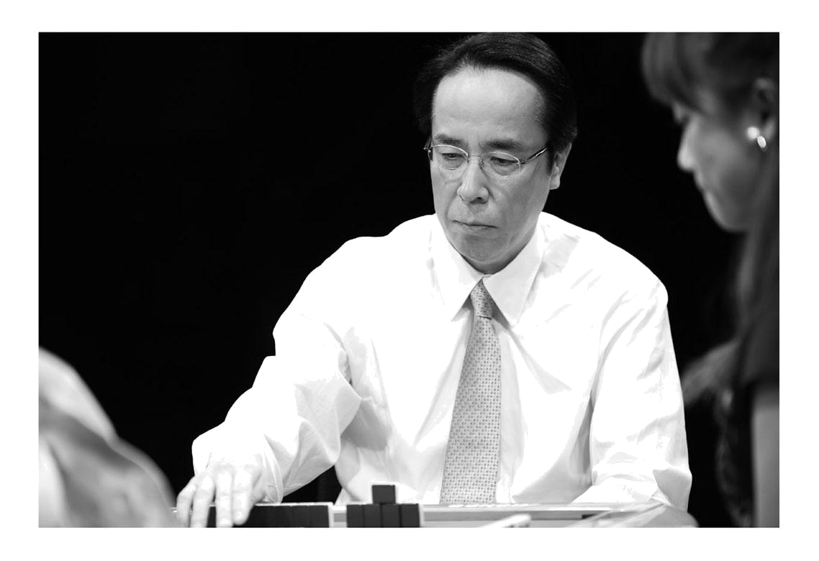

Even if you notice a ri-ten after declaring ri-ten, you don't stop the action, even if you misjudged the tenpai and it was a false ri-ten.

Just as there is no "no, wrong, wait a minute" in life's choices, there is no rewind to replay in mahjong.

Let's not do it this time and try it again next time I get the chance. You can't make this choice either. There is no "again" in the choice. You are merely postponing a conclusion.

It's human to grow through failure. We need to experience failure for growth. Success and failure can only come from challenges.

So when you play mahjong, you need to always play with a load.

"Don't cut the tiles on the first turn.

It's one of the loads I put on myself.

It's more important than "what to cut”.

In terms of the order of arrival alone, there are plenty of times when a professional can be beaten by an amateur. And if you are a confident amateur, you probably think you can beat the professionals. Perhaps you're watching a show where the pros are playing against each other and thinking, "What the hell are you doing?! You suck! And the yapping should be flying.

In such an obscure world, there are over a thousand professionals.

Rather than winning or losing, what part of mahjong can be conveyed to enthusiasts? It is the role and mission of a professional to ask himself or herself the question, to convey it in easy to understand words, and to actually express it and show it to them. Without that essential pillar, technical terms such as "what to cut" will be difficult for fans to understand.

We want to be thought of well by everyone. It's human to want to be thought of as special, but if you're a professional, you should be rather pleased when people say they don't like you. People rarely appreciate you the way you want them to. That's normal, so as a professional you don't have to worry about what people think of you.

The saddest part of being a professional is being told that you don't love it or hate it.

"It's a blessing to have an 'anti' It's the kind of person who says "No, I don't like it," and yet you can't help but want to watch it again. I'm sure that person has some kind of

I think it's fascinating. It has the power to make you want to watch it because it has the power to make you care. It's the same with actors who are popular as villains.

I'm going to lose quite a bit, but I kind of want to support him. I want to meet him and hear him out. I would like to meet and listen to them. I feel that if you're a professional who feels that way, you'll be more likely to succeed.

In order to do so, it is essential to improve your ability to express yourself.

Expressing yourself as a mahjong professional means having a character that can be entertaining. It doesn't matter how strong or weak your mahjong game is.

In the future, there will be no shortage of people with the skills of an "expressive person" to draw on.

Just about anyone has a chance to be a part of it, but there is no place to be taught it. Actors can't be trained without training schools. It is impossible to become a full-fledged actor if you don't learn the basics and develop your ability to express yourself.

In order to hone your expressive skills, it is very helpful to go to see what people are performing, whether it is Rakugo, Kabuki, Takarazuka, movies, or the circus. The audience's reaction to a first-class performance is a great way to learn the empathy points that connoisseurs like to see.

I was fortunate to be in an environment where I could learn to express myself, including those fundamentals.

My foundation is that I have been teaching mahjong classes since I was in my twenties. In the classroom, I have to capture the interest of students of all ages in an instant. Where are the pressure points that make them relax? Where are the pressure points that make me laugh? Where is the pressure point that tickles my curiosity?

I was learning my own skills as an expressionist through the classroom.

The Difference Between "Live Action" and "Commentary

In 2006, "Nico Nico Douga" started its video distribution service. Since then, the internet TV station "Abema TV" appeared in 2016, and the number of games played on the network has increased dramatically.

This has led to a new demand for "game commentary". However, unfortunately, there are many professionals who do not understand the difference between "play-by-play" and "commentary".

The actual situation is to report on the situation as it is going on at the moment. Commentary is to explain why it was done, what it means, and the main points.

You're sitting there as a commentary and you want to say what you see immediately. That's the role of the play-by-play. A game show can look completely different depending on the commentary, yet all you hear is sweet commentary that is completely unspiced. Simply talking about something that doesn't hit the mark so as not to attract criticism is disrespectful to the players.

The role of the commentary is to convey information that the audience does not know. It teaches us what we don't know and yet there must be a sense of drama in it.

Dramaturgy is a person's personality that is the source of an opponent's actions. Of course it's impossible to tell everything, but viewers receive information in a variety of ways, so your imagination can grow even from fragments of information. It can be about what motivated you to become a professional, or an episode about your favorite role or tile. If you convey the personality of the player, such as their pre-game routine, the obstacles and challenges they are trying to overcome, the viewer is more likely to get emotionally involved. It does.
and the thoughts of each stroke are read from the screen by the viewer.

That's where the role of the commentary is to follow and inflate it.

It is also the role of the commentary to imagine the psychological state of the player and to convey the tension on the table, the thoughts and psychological transitions of the situation.

The players are always serious. There is no mediocrity in that seriousness. It's only mediocrity if you can't scoop up that seriousness as entertainment.

Even if the game is lost, the commentator knows how many tiles are left and whether or not there is a waiting tile, but the players don't even know if the game is lost or not. All four players must feel a sense of urgency at all times during the game.

In order to feel those things, you have to get into the table to realize how you feel, too. Don't read the tiles, read the mind. It is necessary to create an opportunity for viewers to become interested in something seemingly difficult to understand. If you talk about a commonplace story, it won't resonate with the viewers' sensibilities and they will end up saying, "Yes, that's true.

You have to cut a different angle that is fresh for the audience. It's up to each professional to figure out what that is.

There is plenty of material in our daily lives that we can learn in our explanations. You can learn by reading, by listening, and by watching. If you have good taste, you can learn from anywhere.

In the field of professional baseball commentary, Mitsuhiro Ochiai has the power of words. In marathon commentary, it's Akemi Masuda, who gives us detailed information about the contestants that is not available to the viewers. These two are very informative and helpful.

Building True Communication

After becoming a professional, I was able to have my own classroom, which I had always dreamed of doing, and I was able to have my own classrooms.

Our mahjong classes have been running for more than 30 years. More than 30 years have passed since then, and our total number of students has grown to more than 10,000. For me, this is a perfect example of how

stone monument

It is the cornerstone of the mahjong promotion program.

When I started, I just watched my students play mahjong in a frantic manner without knowing where to go from here to there.

When I was watching the students' every stroke, I saw that the theorems of mahjong were collapsing at every turn. I had to help the students learn the correct way to play mahjong. With such a strong desire, the way of playing and thinking

I began to handwrite and compile the directions, and then print them out to explain them. When I tracked down the back issues, I found that there were more than 5,000 of them. I had no choice but to go straight ahead, and this seemed to represent the person I was.

The students are not aiming to be professionals or to win all the time, but they come to the class to have fun and learn. But at the time, I had no idea how my students felt, and I wanted them to get as good as possible, or to increase their knowledge of the game.

I was working hard at making prints for somewhat arrogant reasons, such as the fact that I would have received them. However, those massive prints resulted in a change for me.
It was helping me grow as a person.
When I look back and look through the printouts from that time, I see that they are poorly written
Aside from that, the text was also difficult to read in many places, and the history was piled on to the point of embarrassment.

However, as I have accumulated many things, including my own games, my response to my students has changed.

When I first started the class, many of my students would leave with a tired look on their faces when they saw me leaving. They were nodding off in defeat or regretting something that hadn't worked out. It was all my fault.

I want to win.

I'd like to be aggravated.
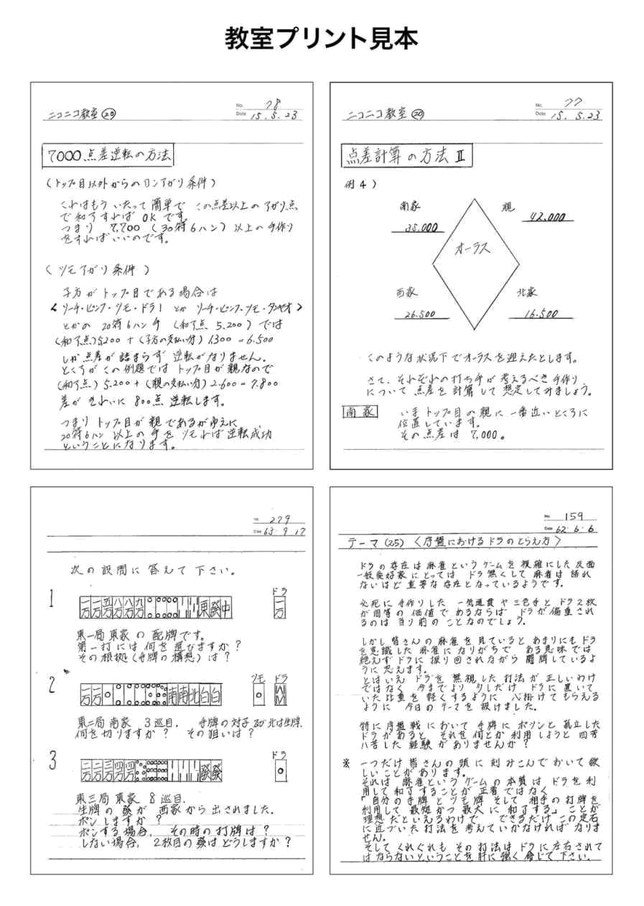

I want to be on top.

Everyone was playing with that kind of selfishness, so I knew this was not good, and I was looking for an answer. In order for people to become familiar with mahjong, we needed to make them unaware of that part of the game. If that's the case, then it's not a big deal to win. It may be fun when you win, but you can't make them only seek for the taste. I strongly felt that if we didn't do that, we would never be able to unwind our students' minds.

If some people win, some people lose, and as long as there are four of us playing together, there is no shortage of things to lose. Then it becomes a question of what you lost against.

It's not about the point sticks you see, or the order in which you land, or any other criteria for winning or losing. Let's not beat ourselves.

This is the standard for winning and losing. Losing to yourself is a loss; losing to your opponent is not a loss. That is not the essence of mahjong.

The essence of mahjong is to develop and enhance yourself. It is a game where you compete with your opponent

It's only empty if you see it as a meme.

Rather than deciding how to line up or what to cut, I want to continue to tell the infinite power of 136 tiles to as many people as possible. And how to deal with 136 tiles. If you don't understand the essence of the game, you're afraid that it will end up as a mere game.

Most importantly, I have experienced the amazing power of Mahjong to bring people together. Mahjong also gave me the strength to become a full-fledged human being.

The scope of our activities has expanded over the years, and now we are able to hold classes in Sapporo, Tokyo, Osaka, Fukuoka and Hiroshima.
With the rapid evolution of communication tools, the speed of information transmission has increased dramatically. Under such circumstances, the "face to face" classrooms may be going against the times.

But that's why I am blessed to be able to share face-to-face time with my students in the classroom.

The word "communication" comes from the Latin word "Communicare", which means to share or share. Communicating what you think is not enough. I would like to continue to share time and space with my students and deepen our mutual understanding while building true communication. I sincerely hope that we can continue to share time and space with our students and deepen our mutual understanding.
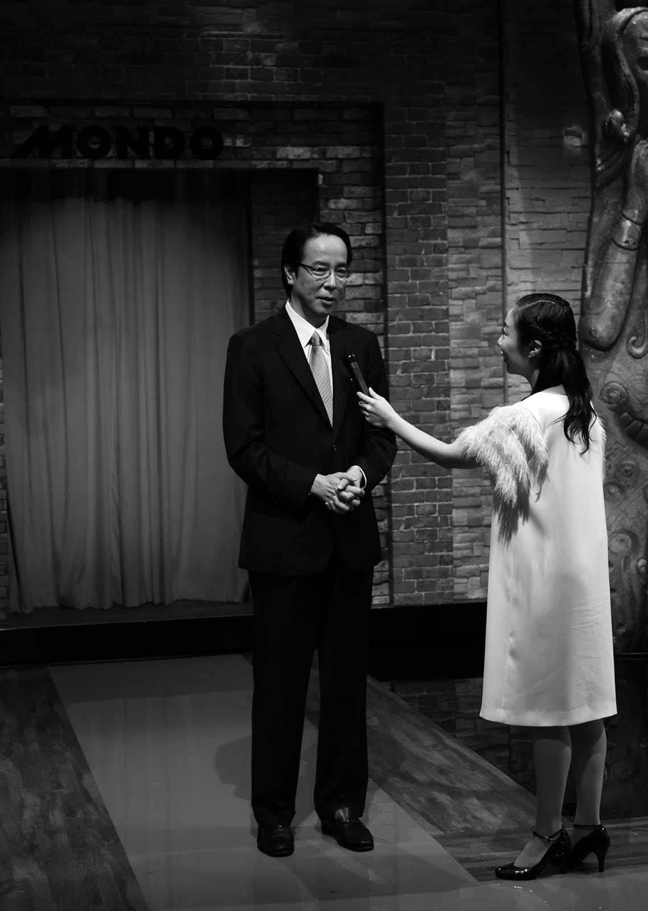

Chapter Four. Improve your luck.

The spirit of "Paihin Gao”

"Tile size.”

It is read as Pai Ping Khao. It may be the first time you hear the word.

It means the posture to strike with dignity.

I was inspired to think about these words when I was asked to appear at a talk event and heard the following concept.

I hope to convey the appeal of mahjong to people who are unfamiliar with the world of mahjong.
The venue was not a mahjong restaurant, but a restaurant with a screen.
What is the best way to convey the appeal of mahjong to the audience?

When the name of the event was decided to be "The Best Recipe for Being Loved by Tile", a lightbulb came to light in the midst of the gloom.

Because I've made the connection that "someone who is loved by the tiles" = "someone I'd like to see again.

A person you want to see again in mahjong is a person who is loved by his or her peers at the table.

The spirit of Tuihingao is to show respect to the tiles and the players at the table during the game.

If this is defined and translated into everyday life and communicated in a way that is easy to understand, it will help people who have never heard of mahjong to imagine what the world is like and you can get it. That's what I was convinced of.
As a mahjong evangelist, he has found a "path" to which he can dedicate his entire being.

As a mahjong "seeker", I would like to aim at "conquering" which is more difficult than "winning".

Everything was connected as a path.

I want to be strong. To everyone who wishes to do so

I want to be strong.

I want to be good.

Many people, both professional and amateur, want that in any sport.

I think a lot of people forget that there is a basic premise that is necessary to just get better and stronger. On the contrary, some people don't even realize it.

Technical and comparative arguments sound plausible at first glance, but there is nothing but complacency and self-defense in them.

The basic premise you need is to be someone who is loved = someone you want to see again.

In order to do so, it is necessary to develop a "kind heart" and a "beautiful mind" as a human being.

This is where the significance of cultivating luck lies.

"In order to nurture our luck, we have to nurture our own heart.

"We are not looking for skill and strength, but for kindness and beauty. Go. That way, you'll be more likely to win as a result, and your luck will love you, and you'll be stronger.

Winning and losing are a given in mahjong. Losing factors are recognizable, but winning factors are not. Losing is inevitable, winning is an accident.
As a result, we just won by accident.

"What is Mahjong trying to tell us humans?

Why does it take four people to do it in the first place?

We don't need technical theory to pursue immediate wins and losses. The tiles are manipulated to make use of small, ad hoc techniques.

Until you break away from this idea and get away from the world of numbers, such as probability and efficiency, you will never get close to the essence of mahjong.

Unless you are willing to give up selfishness and take the position that you are being taught by the tiles, it's impossible to build a foundation.

In reality, humans are more often manipulated by the tiles. If so, we should listen to what the tiles are trying to tell us.

That's why.

There are 136 tiles. Among them, 28 honor tiles. The remaining number tiles are 108.

That's right. It is the same as the number of worries.

Probability, efficiency, and self-interest. The commandment not to be blinded by the selfishness of vexation, which afflicts, torments and troubles the body and mind.

That's what the tiles are communicating to humans.

Take the initiative

"Manners" and "etiquette".

Manners are consideration for others. Manners are the way we behave and look beautiful.

Many people think that manners and etiquette in mahjong are something that can be learned naturally, and many people think that they are fine.

But in reality, most of us seem to be able to do it, but most of us don't. In no other competition is manners, the most important part of any sport, are neglected as much as they are.

The reason for this is that there is a history of prioritizing only technical matters in learning mahjong, such as "to win" and "not to lose".

Manners and gestures form the framework of dignity and dignity that should be cherished throughout one's life, before one learns short-term skills. We don't understand the essence of why we should behave the way we do.

For example, how to wait for your opponent when he has been thinking for a long time. Click on the tiles in the hand

You can make them chuckle or pretend to peek at you on purpose.

OK

There are people who can rush you.

Even if these actions are listed as prohibited, to what extent are they acceptable, and if they are, will they be punished? There are no clear standards or manuals for this kind of behavior.
There are times when we have time on our hands. The first step is to have a spirit of tolerance for each other.

And when you encounter someone in distress, you should be the "leader" who eases the atmosphere in a spirit of tolerance.

They are in trouble. I'm not doing this on purpose.

I mean, how can you blame someone who is really in need?

In order to be a leader who soothes the atmosphere, one must have the spirit of love and tolerance. The more we resonate in the spirit of tolerance, the more sensitive we are to each other's sensitivities and the more the game is enhanced.

We want you to take the lead in any situation at any time.

When there is a table with such a leader and a good atmosphere, it will propagate to other tables. This will improve the atmosphere of the entire hall.

On the flip side, the opposite sentiment is propagated as well.

When some tables start to get crappy, it spreads to the whole hall, negative resonance starts, a heavy air hangs in the air, and you end up playing while being strangely cautious.

I want you to take the initiative to soften on the verge of that happening. I want you to take the initiative to be a clown if you feel it's not a good idea to leave them alone, or to find the words to undo the feelings of your fellow tablemates. If someone is in doubt, just saying "Mahjong is a really hard game," can make a difference.

When you become a leader, you also grow in luck. When luck grows, it also leads to increased human power.

A simple "mock-up"

A mock-up. This is the most basic of all movements. In playing mahjong, this is the core movement.
First, the "摸" movement. The dominant arm placed on the right or left side of the hand is a castle

Extends to the wall (pile of Tsumo Tiles) and places the Tsumo Tiles to the right or left of the hand again.

In performing this simple action, one must be careful.

The correct timing for the "摸" movement is to start at the same time when the upper family's tile lands on the river and the dominant hand that made the winning move returns to its own position.

What we often see is that Guru starts to play "摸" at the same time as he plays a tile, and he cannot call out "Pong" even if he wants to.

Or the hasty "摸" action of looking at the next Tsumo tile when a "pon" is heard is not a dignified player.

In addition, you must not make a "winning move" which is close to the delayed action. It is unacceptable to look at a player's tiles as if you are licking his or her face, or to start a "Wow" game after being stationary for a while, as if you are trying to figure out the intent of the tiles. Needless delays, such as tilting your head, are ugly.

However, the moment UeJie makes a move, the move stops in its tracks, so it is inevitable that a state of stasis may occur that cannot be divided by logic. However, in your turn, you should try to minimize the amount of time you have to spend on
You want to be aware.
In addition, when the player has a move that can aim at a high score, or when he is conscious of wanting to make a hand that can quickly make a winning move, he may be tempted to focus on the "摸", and the arm that plays the "摸" becomes over-action, or he may waste time on pulling a Tsumo tile, or he may pull too far back from the wall, which is not smooth. There are also many

What we need to keep in mind is to eliminate waste from the "摸" movement anyway.

Be conscious of reducing the amount of time you spend as much as possible on your own, and imagine a beautiful "摸" while playing. Just by being conscious of this, you will be able to eliminate waste from your "摸" movements.

The "uchi" movement. As with the "摸" action, we eliminate as much waste as possible.

This is the act of placing a Tsumoed tile at the right or left end of the hand and "striking" a tile from the hand, but there are some things to note.

Basically, a player must not place a Tsumo Tile back into his or her hand. Tsumo Tile must be placed at the end of the hand when making a "strike" motion.

When you have to put a Tsumo Tile back into the hand, such as in a difficult Chin II hand with a tendency to have complicated waiting tiles, it is better to say "Excuse me" before considering the situation.

Hand wandering is also taboo.

There's nothing wrong with "thinking" about what to cut when you make a bat. The problem is that you are not sure whether you should use this or that.

When thinking about which tile to cut, the dominant hand is stationary on the dominant end of the hand, and the player thinks quickly and thoughtfully before making a "strike" motion.
Enter the work.

Hard or random hitting is, of course, a taboo. When you feel the urge to get upset, or when you lose your composure and your mind is distracted, it is common to see that you put more effort into hitting or hit into a distracted position.

However, if you aim to be a dignified striker, you should be very conscious of the fact that you can improve with a single mind.

You also want to keep in mind that you should have a "strike" that is easily visible to the three other families.

The player must be aware of the importance of cutting the tiles beautifully so that they will not be hidden from the dominant hand when the tiles are struck.

If the tiles are easy to be seen by the lower player and hard to be seen by the upper player or the opponent, it is easy to vocalize "Chi" in favor of "Qi", and it is easy to vocalize "Pon" in a delayed way.

The "greetings" and "posture" that bring in luck

"Greetings.

It is done all over the world, and the way it is done varies from country to country and region to region, but what it shows in words and actions is universal. Those words and actions can be consciously honed and refined.

Greetings are an important part of the mahjong game as well.

I encourage players to greet each other in four different ways: before, at the beginning, at the beginning, at the end, and after the game.

At the beginning and at the end of the game are greetings to fellow players, the table and the tiles, saying "Thank you" and "Thank you". "Before" and "After" are the greetings to the whole party.

I bow to the hall we will use all day, to the management staff, to the people who have gathered for the game, to the tiles we will be using from now on, and to the tables and chairs, saying "Thank you very much. It is the same after the end of the game, "Thank you for providing us with a good time.

And "posture".

Mahjong is not a game of "logic", but rather a game of feeling with your whole body. To do this, you need to maintain your posture.

Ideally, you should maintain a "mid-sided" posture in relation to the center of the table. The midsection is not sitting parallel to the table, but rather with the right side of the table slightly pointed out to the center of the table. To maintain this mid-sided posture, imagine that you are bringing your navel to the center of the table.
The navel and the center of the table will be in a straight line.

When you do this, your abdominal muscles will naturally become tense, your lower abdomen will be stronger, and your entire body will be much more toned. If you don't have strength in your lower abdomen, you won't be able to maintain the midline posture. You need physical strength to maintain it. Therefore, good mahjong is not possible unless the abdominal muscles are exercised on a regular basis.

The distance between you and the table is also important to maintain your posture, so keep a fistful of space between you and the table. Adjust your chair to your seating height, find a position that allows you to keep your back straight and then adjust your chair to a height that allows you to smoothly perform the Tsumo and cutting motions.

The criterion is that you can do all the movements naturally. Unnatural motions, such as making it hard to take, coming out too much, or pulling too much, will make the person feel uncomfortable.

When the posture is entered from the arm instead of the center of the body, the senses do not work. When you smoothly enter into Waza by the shortest possible distance from the center of your body, your senses are sharpened.

When you play with this posture, you can make the first move smoothly and clearly. The first move in mahjong is to pick up a tile and cut it into a piece.

It is important to actually move your body instead of doing it in your head for the first time.

And it's not so much about "what to cut" for the first stroke, but where to place the first stroke. Since kawa proceeds in six pieces, many people carefully line up from the left end. This does not allow for mock-ups from the center of the body.

The place to place the first stroke is towards the middle of the table, which is on the center line between the navel and the table. As you do so, you will naturally feel more relaxed and
If you place a tile in the center of the board, the first tile shifts to the left. From the second row onwards, the first tile is placed in the center, and the first tile is shifted to the left. After the 6 tiles are lined up in this way, the second and subsequent rows of tiles are placed on the left side.

It's not an exaggeration to say that the initial response determines everything.

It's hard to understand how to use your body until you experience it. Especially for modern people, who spend a lot of time at their desks, we should be aware of the midline plane, where the navel is in line with the center of the desk, even when we are working. When you have a posture that allows you to move smoothly from the center, your senses will be sharp and you will be more likely to come up with good ideas.

Strike with your body, not by hand.

I used to do karate, so I know what it feels like, but with awareness, anyone can do it. Even if you enjoy playing mahjong as a hobby, it is better to challenge yourself to play mahjong with your body so that you can experience the true nature of mahjong. If you play with your arms alone, you will play with your mind and not the mahjong style at all.

We'll start with the body.

As long as you think in your head, no luck will follow.

"Sui" means compassion.

"Sui Tile.

This action, which I read as Toipai.

It is a necessary action for the batter at the start of the game, and also during the game. However, since it is not on the rules list, many batters think it is just good manners. However, this is an act that should be considered a duty.

He puts the wall tiles in front of him in such a way that the three other families can easily take them. In spite of the fact that this is all he is doing, he may put the tiles too far forward, put them at too much of an angle, or put them at almost no angle, and may question whether he is really thinking about how easy it is for the other families to take the tiles.

い (musical) note

It should be remembered that the guessing game is an act of respect for the three opponents as well as an expression of awe for the wall tiles.

plank

There is a meaning of promoting a tile only when feelings of "sympathy", "gratitude" and "appreciation" are put into it.

And one more thing.

If the opponent's wall tiles are in a position where it is difficult for you to take the wall tiles or for another family to take the wall tiles, you can push the wall tiles to the side to take the wall tiles.

Acts of kindness are strictly forbidden. It may seem like a kind gesture, but it is an act that must not be done.
Because the wall tiles in front of the other family are the same as the river and the tiles in the other family's hand.
The reason is that "inviolability" is the main principle.

Don't forget that what you think you're helping out with without thinking about it may actually be the worst kind of bad manners.

It is only when you learn the right manners that your luck will be refined.

Knowing how to be a rastmaster

A situation called "lass's eye" is a fate of a bout.

There are various cases of Rusu-moku, so I'll talk about the phase of the game only in the southern third round or in the auras. Regarding the situation of the point-bar, there are cases in which a player can escape from the lass game with makan tsumo, and eventual reversal of the top position is possible, but this is a rare case, and in this article, we will talk about the possibility of emerging into the third or second position.

The first thing you need to consider is to stop hitting just for the point differential.

It may sound resistant, but we should be aware that the field is often disrupted by pointillist thinking in the laths.

Many players argue that since mahjong is an individual game and the main goal is to improve one place in the rankings, it is natural to play with only the point difference in mind before the rus or after the all-rus.

However, a dignified player values "progress" rather than "result". It may be easier to understand if you replace "progress" with "your behavior".

How did they behave from the first east game to the second south game? I want you to check this first.

What impact have you had on the place? Check only your own behavior, not the behavior of other families.

He hasn't destroyed the place by acting in support of the top-eyed people, including careless mistakes, or by acting in an ego-driven manner.

Especially if you have caused trouble to other families by behaving in a way that was accompanied by emotional turbulence, you should be very remorseful.

Humans live with weakness, cunning, and ugliness, and when we suffer, those negatives are easily exposed on the tabletop. We can excuse ourselves by saying, "Because we're human," but we must also reflect on it.

Acting like a russian requires a great deal of "determination".

As the word "preparedness" contains the word "enlightenment," so when there is a clear process in which it is practically impossible to reverse the top spot, or when you cannot participate in the battle for the top spot, you should realize that you have lost that game.

"If" or "If you're lucky,……" because it's mahjong.

Using the dialect of not knowing what's going to happen, the strikes of hoping for a little more

There are many mahjong hands, but this may lead to undermining the noble game of mahjong. It is understandable that the players want to end the game with as little damage as possible, but it is important to play with care so that they do not hurt the competition.

Losing becomes more beautiful when you realize that there is also a resignation in Mahjong. Resignation is not only the act of renouncing selfishness to go to Agari, but also the responsibility to pay close attention to prevent your river from being used by another player.

A dignified batter must be willing to take responsibility for their progress.

"An aurora is not an aurora.

Mahjong doesn't end today. Mahjong doesn't end tomorrow. Next month and next year, the "path" of mahjong will continue.
One of the games that will be played in the future of a lifetime of mahjong is the Auras.

[Preparing for the Aura sphere]

Starting with the game in which you recognize defeat, you play with more concentration than in previous games so as not to disrupt the "place".

To be in control of one's own luck and its highs and lows in an objective manner

Rather than thinking about the difference in points, check out the progress before the lass to see if you have the status to be aggravated.

Even if you're in a position where you don't mind getting aggravated, avoid aggravation that doesn't change your ranking as much as possible.

If your luck is downward and you have an auras, wait with a resignation stance unless your parent plays a series of games.

When you are ready to resign, you must abandon your selfishness and be very careful not to let your river be used by another family.

Don't be selfish enough to only think about how to get out of Las Vegas.

When the auras are on the parent's turn, you should aim to hit for the final shape of your own luck, which is commensurate with the highs and lows of your own luck.

Even if the auras is the parent's turn, you should be able to look at the tsumo until about the 6th round and be ready to resign.

If a ricochet is thrown, be very careful not to discharge a gun into another player's hand with the actual item in riichi.

"Maybe," he said, "maybe." "Maybe." "Maybe." "Maybe.

Making it auras.

Top Tips

When you are on the verge of taking the top spot, you need to be meticulous in your concern for your opponents and eliminate all waste.

When the top spot is right in front of you, there is no denying that you will do everything you can to capture it. However, it is precisely under these circumstances that dignified behavior is required.

First of all, it's time to say "agari". You declare the Go Out by saying "Ron" or "Tsumo", but if there is a proud sound in your voice, the dignity of the player's dignity is seriously compromised. Or, if the player declares a Go Out

You need to be careful not to go overboard with the joy of being happy, and make sure that the volume is not so loud that the joy turns into a winning voice. This is an issue that we should be very conscious of on a regular basis of what it means to speak without sarcasm.

Even when a player collapses a Go Out tile, careful attention to detail is required. Taking too much time to collapse a tile or playing a one-handed tile is unacceptable. The player should keep in mind to play such a way that the three opponents can comfortably see the opened tiles.

One thing to always keep in mind strongly is the reality that when your top position is almost decided, at least two of your three opponents are playing with their hands and hearts in a difficult position. Without taking this reality into account, it is impossible to play with dignity at the top of the game.

When you go out, it also means that someone else will lose the point guard. There is always a "movement of the heart" that follows. That's why when you stand at the top, you have to pay attention to the details and do everything you can to make it happen.
You need to pay more attention to the sound quality of your score report than you do to the sound of your own speech. Even if you can hear up to "Ron" or "Tsumo", it is easy to get distracted by the rest of the game. However, a high-pitched declaration with a winning voice will only make the three opponents feel uncomfortable.

A reserved declaration is even worse. 'What? How many points? If the other person asks you, "What's the matter with you?", you may take up the other person's time.

Consideration should be given to winning moves. When you are in a strong position to win, Tsumo comes in interesting ways. Then, you can see several paths to Go Out, and you may be wondering which path you should take.

At such times, do you ever stop in the middle of a move, or do you ever think, "Wait a minute," and play a different tile when you are about to cut this tile?

It is preferable to avoid getting lost in the middle of a race, knowing that it is a shame.

Also, as the rhythm of Tsumo improves, the rhythm of the playing tiles becomes lighter. Then, before you know it, the tempo becomes up-tempo, and this may lead to intimidation of the lower family. It seems as if the player is saying "I'm in good shape!

Yo! It's not a good idea to scatter the atmosphere like this on the table, so you should try to make a dignified, top-notch mock-up.

If you can eliminate all wastefulness and play a game that conveys a clear "heartbeat" to the tiles, you are sure to gain the respect of your three opponents as the top player with dignity.

[Preparing for the Aura Top Zone]

When your top position is almost decided, the player has a hard time with both his tiles and his mind.
I want to keep in mind the reality that I'm playing in the same place.

To be in control of one's own luck and its highs and lows in an objective manner

When you're feeling lucky enough to be at the top of your game, be mindful of your ability to take full advantage of that luck.

Be aware of how many moves you're in a position to make and the highs and lows of your luck rather than understanding the point differential.
When your luck starts to wane and you get an all-russ hand, you have to surrender to your East player's consecutive games. However, if the first position is lass, keep the second position.

When it's your turn, think carefully about whether you can roll all the way through or not, depending on your luck.

Don't forget to care for your opponents in your speech and every other gesture.

If you're on top and you're upset in the auras, feel good about the outcome.

Complement each other

We are human beings with many shortcomings. No matter how good we are, we can never live alone.

We are able to live because we complement each other. Therefore, the ideal is to create a community where people can feel "happy" with each other while compensating for each other.

"Happiness" is abundant in our daily lives. Happiness isn't the result of having lots of money or status or honor. It's being there and having a community that makes you feel comfortable - that's what makes you truly happy.

My goal is to create a community where everyone always has a smile on their face and can share their mahjong time. As you grow to love the good things about your fellow players in the community, you'll want to come back to see them again. We don't want to make a big show of glitz and glamour, but we want to create a community where people can communicate with each other from the heart. It's a community where you can communicate with each other from the heart. Even if some people are selfish in the beginning, the ideal situation is for them to come to understand each other, understand and accept each other through mahjong.

This is the reason why we are able to offer mahjong classes all over the country.

"Today is the day I get to go to mahjong class! I'm happy to be a community that is able to compete with

This warm community through mahjong is the origin of my childhood experience of family mahjong.
The family mahjong was spearheaded by his mother. A very typical bad side favorite. Mother.
My parents played a crazy game of mahjong, but looking back on it now, I think that's how they made everyone around them feel at ease.

His father is a winner. His brother is someone who is happy to lose. His mother is the one who takes the initiative to make the situation more relaxed.

That was the role of the family mahjong community.

The ten worst in the world.

"Turn your back on what you've done and turn your back on yourself.

Even if your mahjong game is excellent, a person with bad game manners will not be considered as someone who wants to play again. Often the person in question is completely unaware of it, and it can come out at a moment's notice.

Below is a list of the 10 worst "low tiles" that are the antithesis of "high tiles". As a reminder to myself.

The ten (ndr 9) worst in the world.

- Complaining

- People who are stingy with people's aggravation.

- People who are stingy with people's pretensions.

- Throwing When cutting a tile, the person who cuts as if he were throwing it, The person who passes the point stick, The person who serves as if he were throwing it

- Kacha-kacha, a person who overacts more than necessary when playing a mock game

- You can't hold on to the tiles until your turn comes, or you get frustrated and don't ring the tiles person who is doing wreck

- People's Mountain, People's Hand Tile,People's Dim Sum, People's River Breaker Commentary

- A person's soliloquy explaining how he or she came to be involved in his or her own aggrievement and pretending. He was reflecting on the previous station and mumbling to himself about the station's progress. Exile sorrowful words. Oh, jeez. "I failed! Ahhh! And people posture to say lines like it's the end of the world.
- I've played games with my elbows in the air, or I've gotten tired and folded my legs or arms.
- Straight thinker overtimePeople who stop every time it's their turn and spend their time being mischievous.

There's still a lot of "low tiles" out there, but I'd like to try to banish these worst 10 completely first.

It is also worth mentioning the typical "Tile Value" game etiquette that many people tend to forget.

The button to open and close the table must be pushed by the master of the next round. Don't let anyone else push the button just because you want to play quickly.

Dora must be opened immediately. Remove the tile from the deal and remove the Reindeer tile at the same time.

Then, open the door (to prevent the tile from spilling over and being seen).

When handing out a point stick, think carefully about how you will get it in and out later, and try to hand it out in a way that does not require you to exchange money in the middle of the day. If you need to exchange money, do it between the Bureau and the Bureau.

Eliminate hesitation. When in doubt about a tile to be cut, move your mind without moving your hand.

Always use a side table to fill out the report card, not a tabletop.

Grade matching is encouraged. If you have your own report card, put it on the table and count it in plain view.

Encouragement of guessing tiles. Keep in mind that a wall tile must be placed in a position where the opponent can easily take it at any time.

We should always be mindful of our three opponents and love our tiles in a comfortable environment.

Respect for the tiles

The tiles are always watching you. You are not looking at the tiles; the tiles are looking at you.

In that moment when I take the tiles and the 13 tiles appear in front of me, I say to myself, "I'm going to play this game.

be (a person)

'I'm glad you're here. But I don't think we'll ever have this crew together again. Thank you.

Thirteen tiles that meet in the dealings. After that, the encounter and farewell are repeated. The way they have a sense of gratitude without being attached to each other is just like a human being, a once-in-a-lifetime encounter.

When viewed in this light, it is clear that words like "unnecessary" and "discard" that are used casually while playing mahjong sometimes hurt the hearts of the tiles.

We forget that these 136 tiles of 34 different types of tiles help us in every possible way.

Do you ever think about those times when you get an unlikely to be able to get a decent deal, or when you don't get any good tiles at all after winning Yi Shantian?

"Bad tiles.

"There's a lot of wasted time.

"You're not gonna have much luck. You're really unlucky.
People who only handle tiles very carefully when they are unfolding in their favor.
There are some, but the tiles are dumbfounded. And they are sad.
Take a good look at the 13 tiles lined up in front of you. What those tiles are looking at is,…… yes, your heart. When.

That's right. The tiles are watching you whether you are playing lightly in peak performance mode, happily in woozy mode, or huffing and puffing in euphoric mode.

And when they are sick, when they are in a sandbagged mess, when they are in a throw-away mode, when they are tired of their opponents, and when they are feeling desperate and desperate because they hate to lose too much, the tiles

froth

I stare at that pity of yours.

Why not show more respect, treat the tiles more carefully and talk to them more often, as they are the most important part of your mahjong life?

'That has nothing to do with tile efficiency, it's a waste of time to think about it.

That's why they call me an occult sparring matchmaker.

I'd like to say this out loud to all of you who love mahjong, despite such criticism.

You are not looking at the tiles; the tiles are looking at you.

You can start tomorrow. When choosing something from your hand, why not stop thinking "I'll throw this tile away" and start thinking "I'll say goodbye to this tile".

And instead of calling the place where the farewell tiles are lined up, I want you to call it a "river" instead of a "discarded tile".

The reason I say this is because I want you all to get to know the tiles that are looking at you better.

And then he gets to know the tiles and says, "I want to be stronger" and "I want to be better”

We want you to be able to fulfill your wish to be and know more.

I want you to grow your tiles, grow your luck, and grow your heart.

I'm still an inexperienced hitter.

I hope that we will continue to work together to create a battering ram that people will want to see again.

Kosho Tsuchida Kosho Tsuchida

He was born in 1959 in Osaka, Japan. He is a special advisor to the Nippon Professional Mahjong Association.

Favourite roles: 4 dark chunks, 3 color orders, 7 pairs

Favorite tile: Middle

Food to eat before the game: fox noodles

Favorite color: pink.

1986. Became a professional in the third year of the Japan Professional Mahjong League.

1992 Winner of the 2nd Pro Grand Prix

1994 Eleventh Houourai

1996 The Mahjong Dream Dojo health mahjong salon opened.

1997 9th strongest rank.

2000 26th Throne.

2002 Winner of the 3rd Mondo 21 Cup

2005 The 22nd stage of Phoenix / 22nd stage of 10th position

2006 23rd J-dan / Winner of the 7th Mondo 21 Cup / Winner of the 4th Mondo 21 Championship

The Japan Professional Mahjong League was resigned. The Japan Mahjong Organization was established.

2007 Winner of the 8th Mondo 21 Cup

Member of the Real Mahjong Unit (RMU) 2009 Mahjong Academy (Tokyo)

2010 Mahjong Academy was opened in Osaka.

RMU withdraws from the RMU. A temporary suspension of the Japan Mahjong Organization is announced.

2011 Joined the Nippon Professional Mahjong Association.

2013 Hotel New Otani Premium Healthy Mahjong Class started (Tokyo)

Mahjong Academy opened (Fukuoka)

2014 Mahjong Academy opened in Sapporo.

2016 The "Mahjong Therapy for Cultivating Tepai and Cultivating the Heart" opened in Tokyo.

Kosho Tsuchida official website

http://www.tsuchidakosho.com

Postscript

When I finished writing this book, I realized "my roots".

My father died when I was 20 and my mother died when I was 26. I don't know the criteria for measuring the length of time we shared, but the intense commun

There is no doubt that they were sharing their location.

The roots of my views on the nature of things were influenced by my father, and the roots of my behavior and words and actions were influenced by my mother, which has made me the person I am today.

I'm ashamed to say that I now understand that he was always teaching me what I needed to value in life and what I was lacking.

I was raised by my mother who told me to be sensible.

I was often scolded for my behavior in public. You just can't do that.

"Be prepared to listen to what they have to say.

You mustn't stand in front of people.

You must not interrupt me.

Take a step back and put them first.

You just need to watch your language.

It was something that had been told to me severely and repeatedly.
The foundation of my daily behavior was built on the teachings of my mother.

You're a good-looking guy, so don't get too attached to your figure.
Every movement is a matter of feeling, so do it from your heart.

He realized that the spirit of "Tile High" that he wanted to pass on throughout his life was based on his mother's teachings.

そ and others

２０１６年 Thinking of the Universe

Kosho Tsuchida
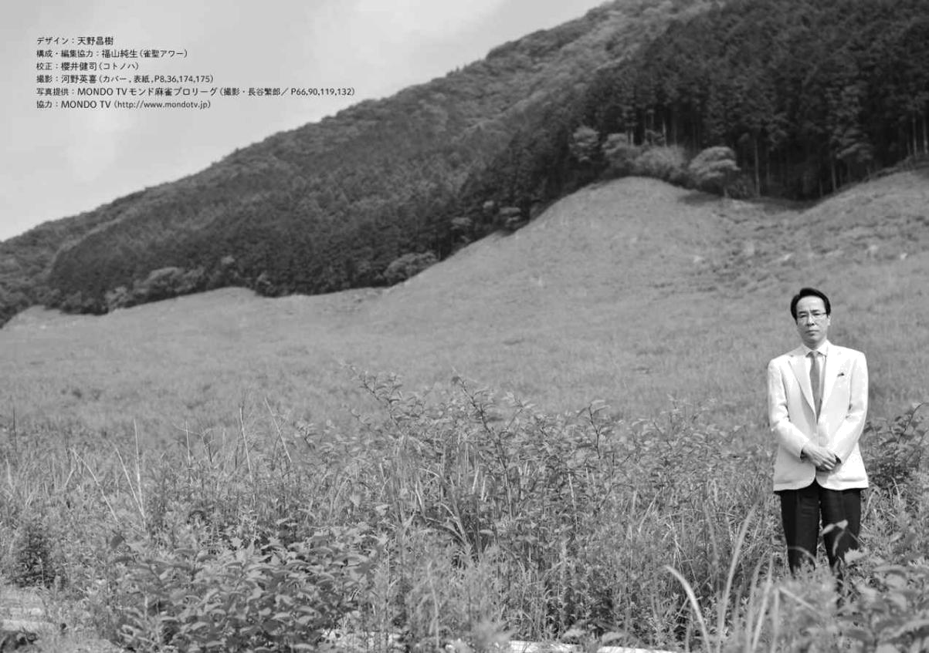

[About the Author]

Kosho Tsuchida

Born in 1959 in Osaka, Japan. While he was a student at Otaru University of Commerce, he won the national championship in the 3rd Nikkan Sports Amateur Highest Ranking Tournament. In 1986, he took the professional test of the Japan Professional Mahjong Federation and passed it in the top spot. In 2010, he resigned from the RMU. In 2011, he joined the Japan Professional Mahjong Association for the highest ranking matches. There are many titles such as "Houou-rang", "Saikyou-rang", "O-rang", "Mondo 21 Cup" and "Judan".

